Project Name: ONLINE SHOPPING APPLICATION

Technologies:

* HTML5
* CSS3
* JavaScript
* AJAX
* JQuery
* JQuery Templating

Description:

It is a web application intended for easy online shopping. It allows the users to

search the products easily based on categories and add them to cart. The user can add to the cart or remove from the cart, any product at any time. Moreover, the user can maintain the variation of quantity of product selected from product to product. There are different images available for one product so that user can have a look at the different variations of product available.

There is also an Admin module. The admin adds new users, adds new products and modifies the existing products’ price.

Role:

* Worked at the front-end at both admin and user modules.
* Developed the pages from the mock-ups and worked for the interactions.

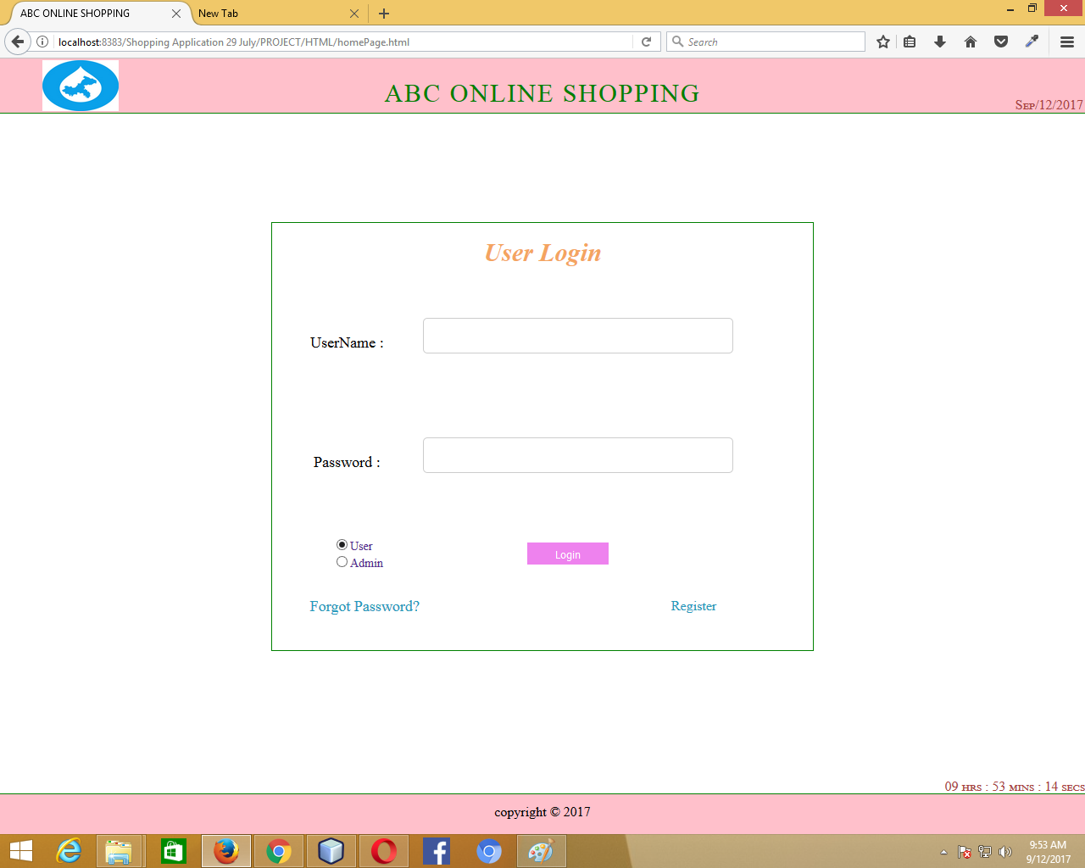

User Login

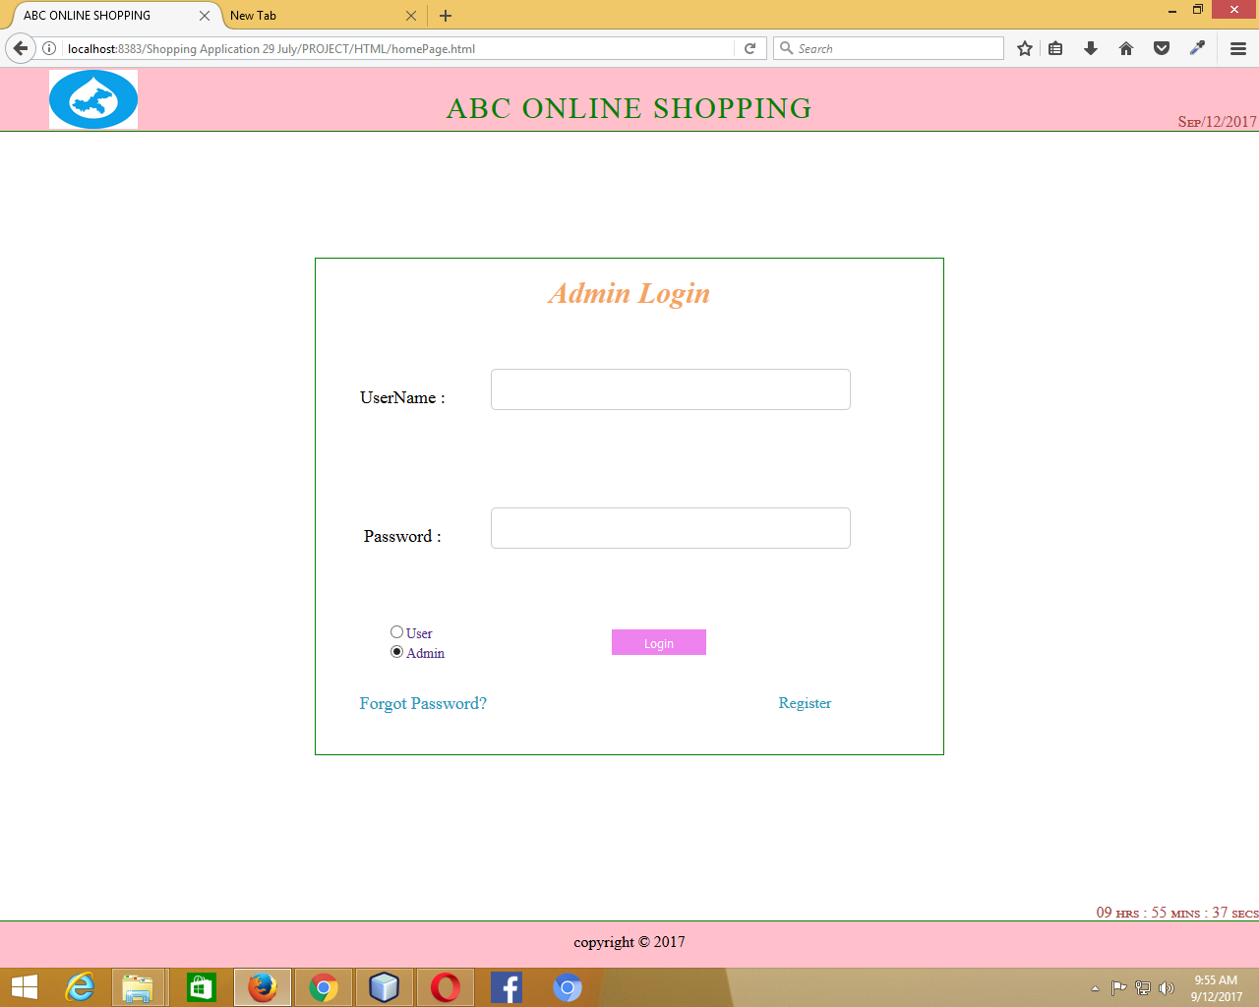

Admin Login

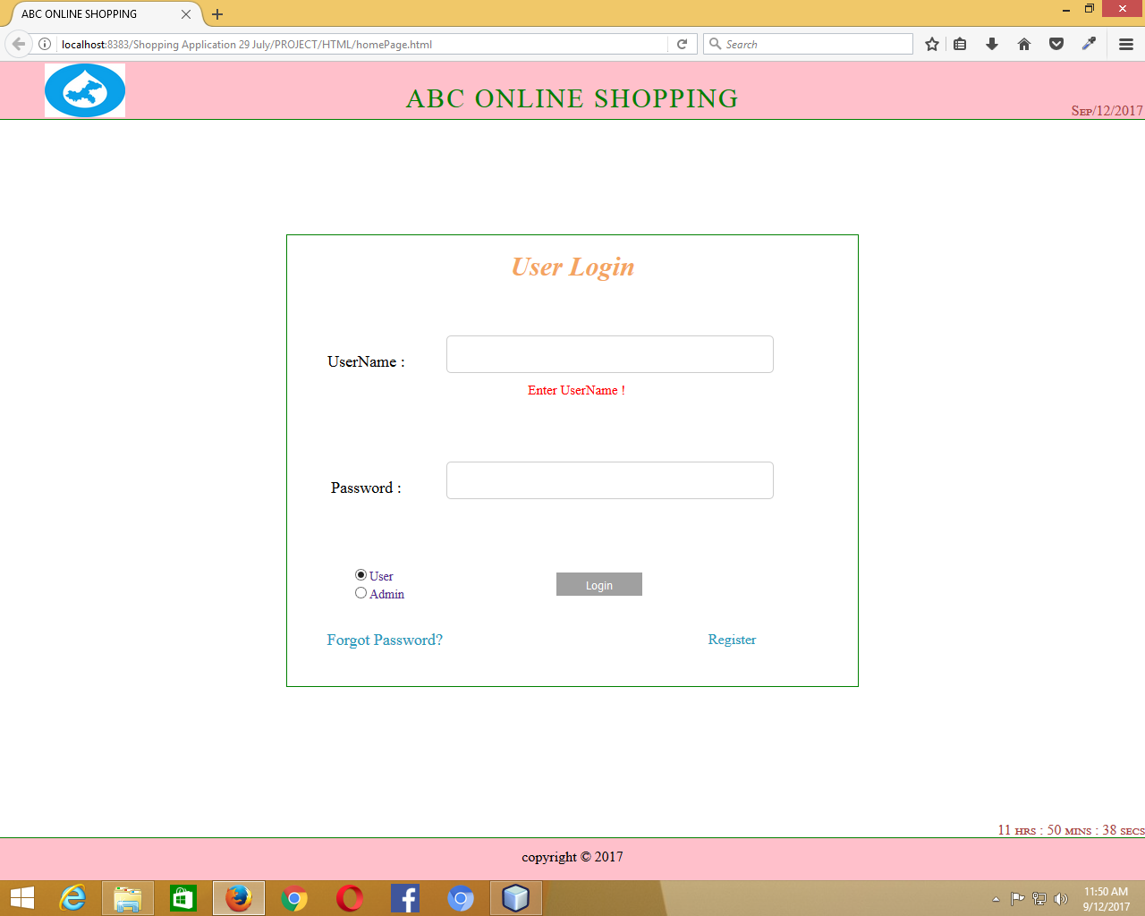

When the text box is focussed in and left focussed out empty

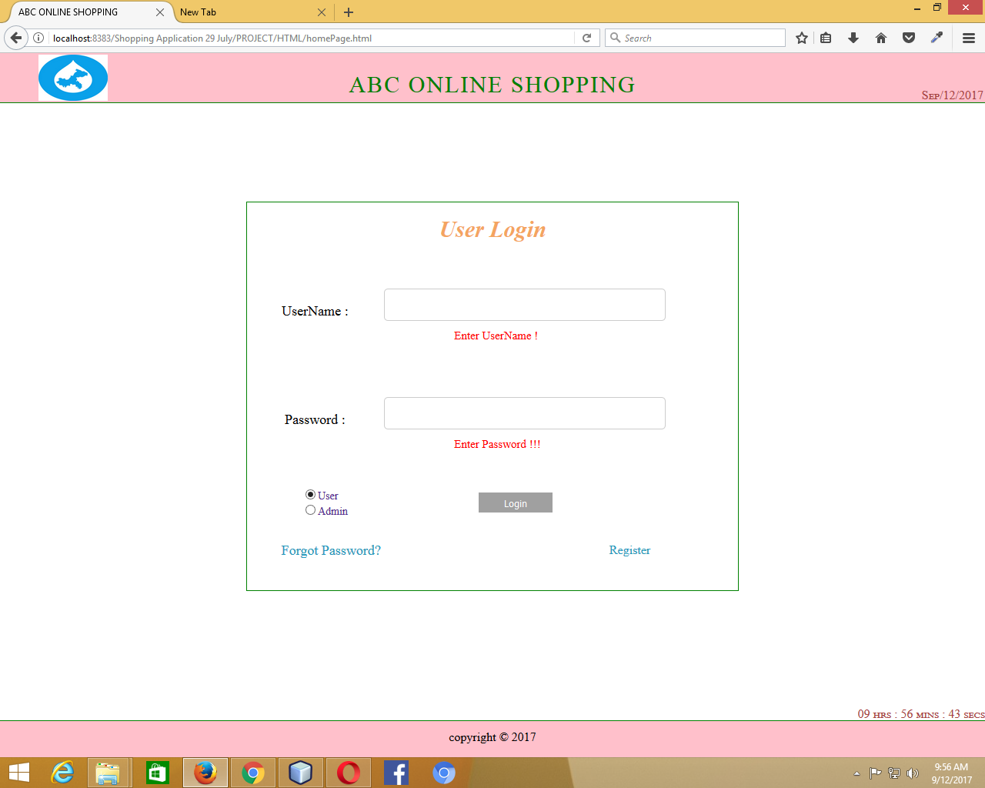

When both the fields are focussed in and left focussed out empty with no data in them

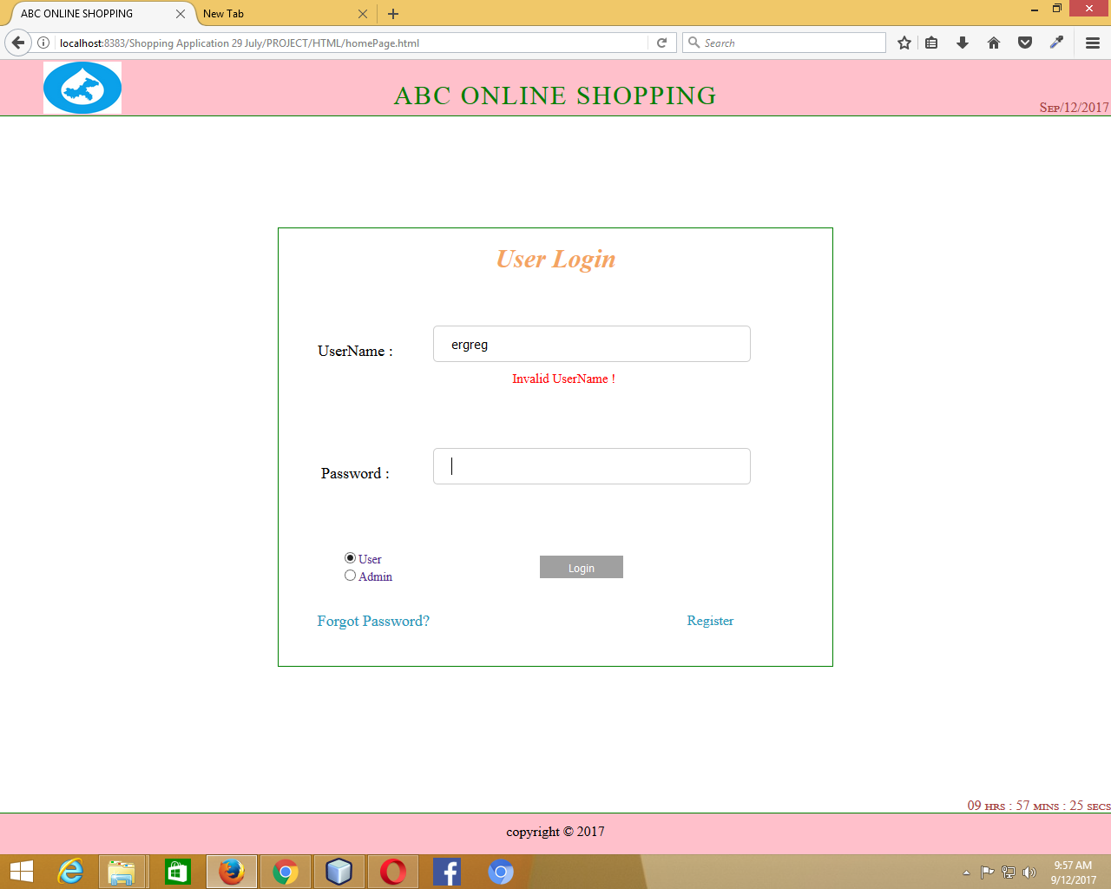

Invalid UserName

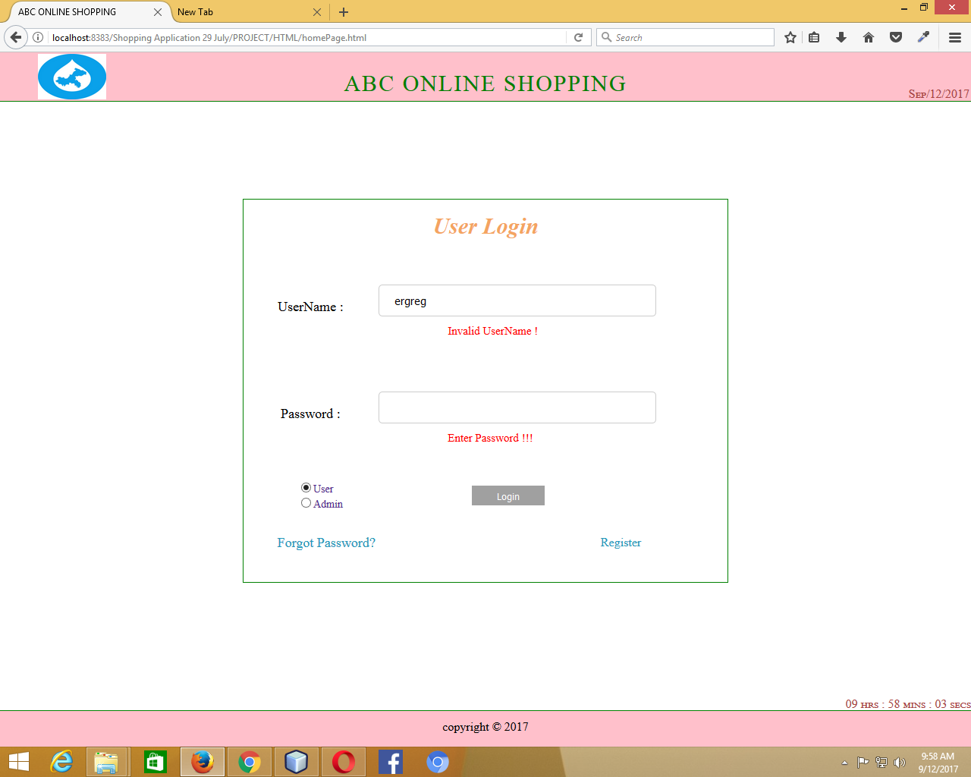

Invalid UserName and password is focussed in and out with field empty

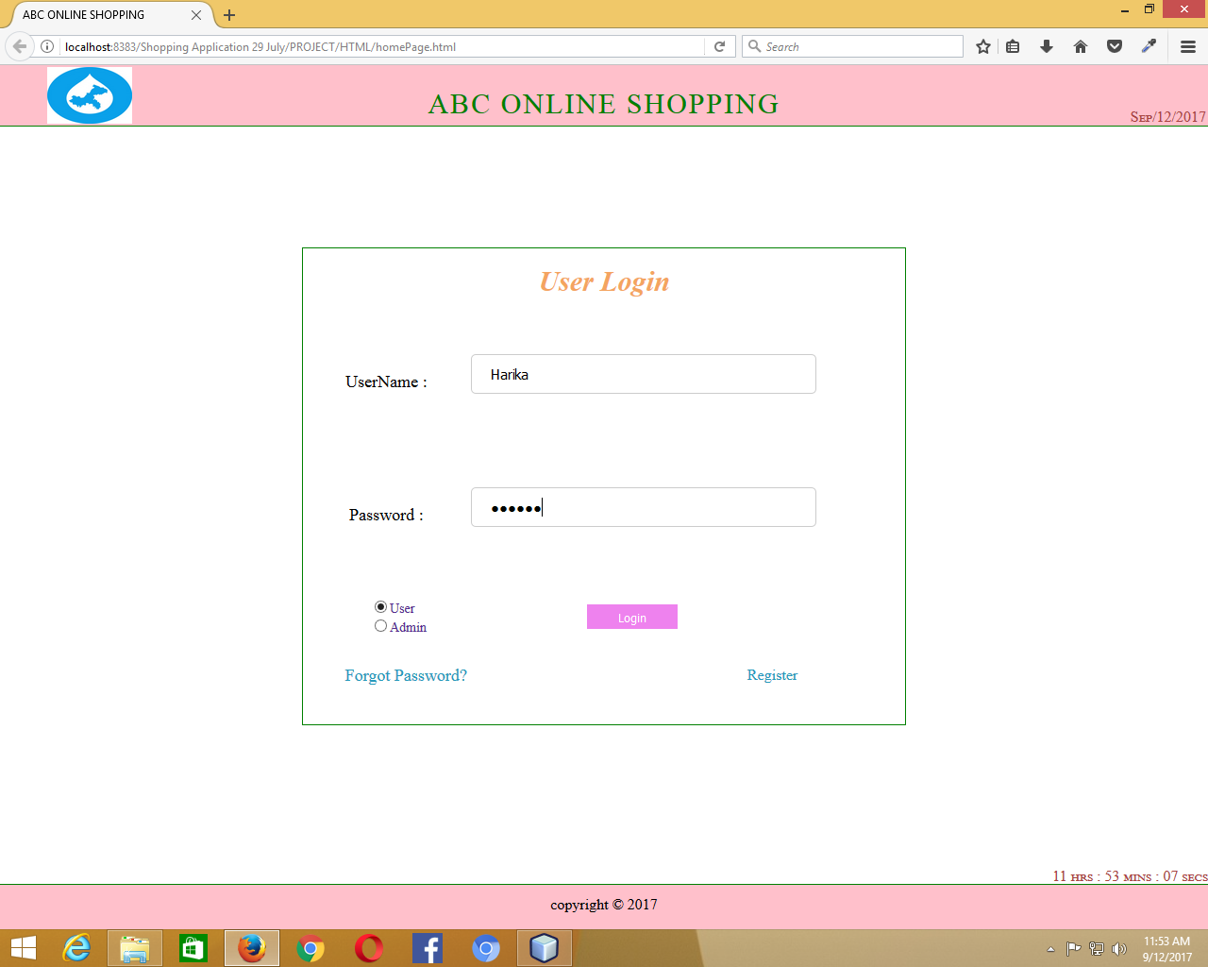

UserName Correct and password entered

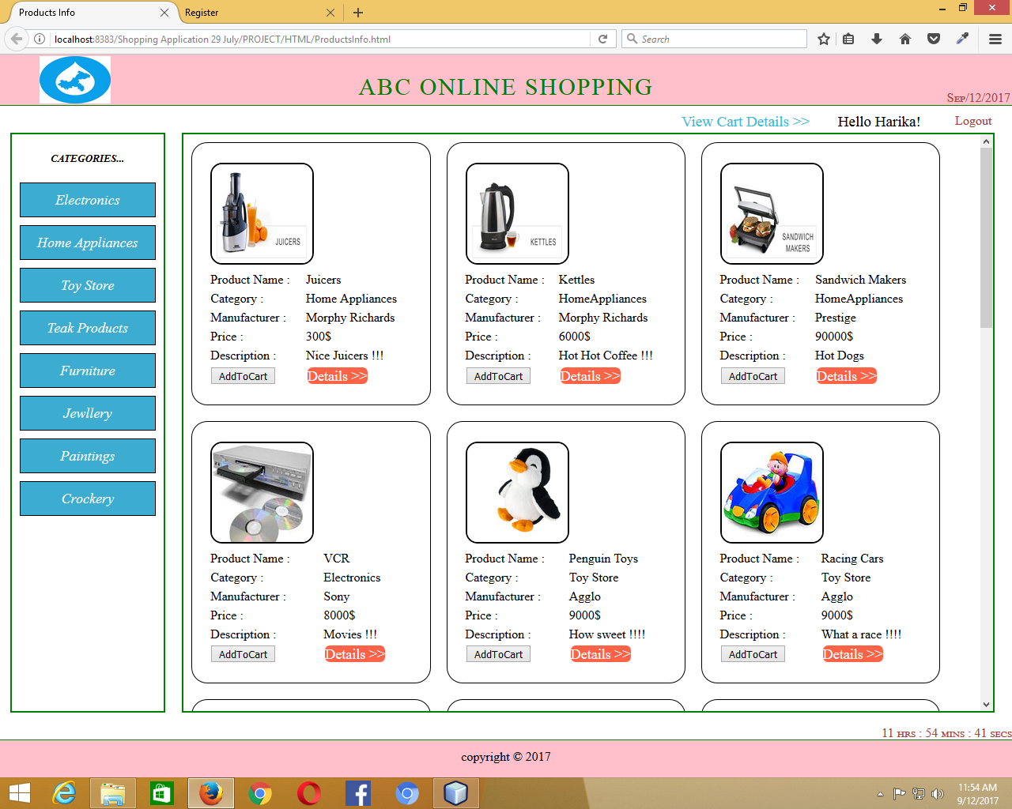

Products after Login (All Categories)

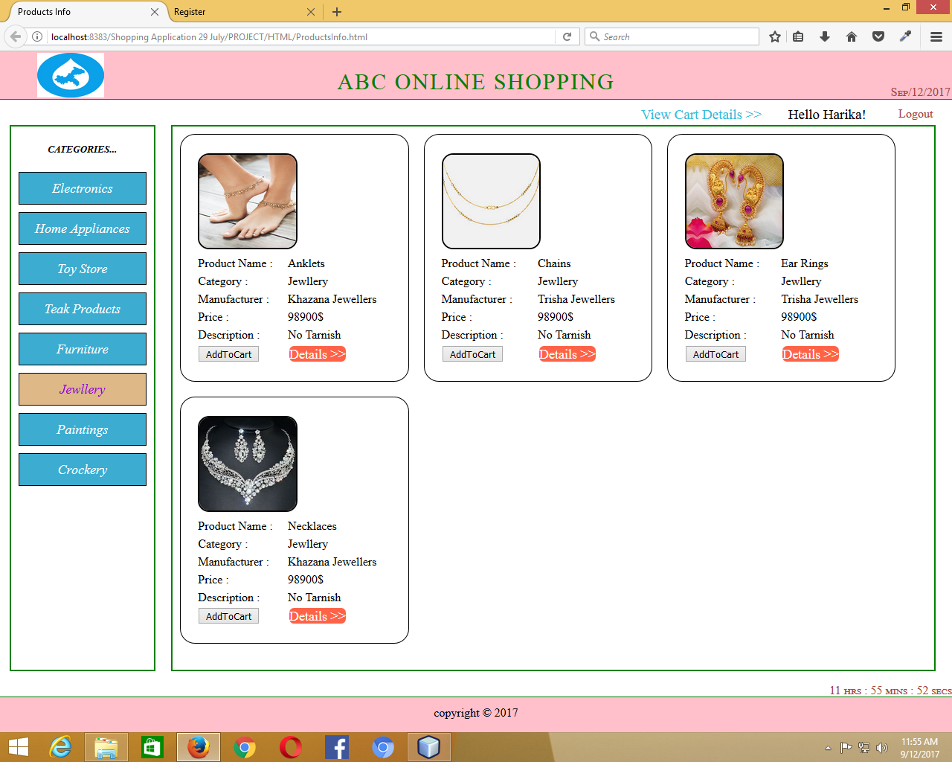

Products according to category (Jewellery)

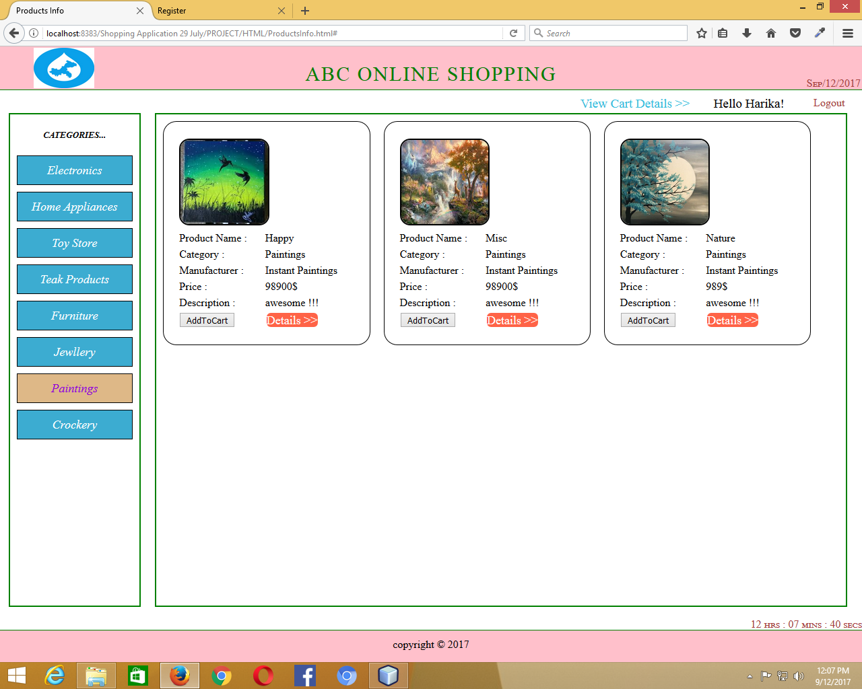

Products according to category (Paintings)

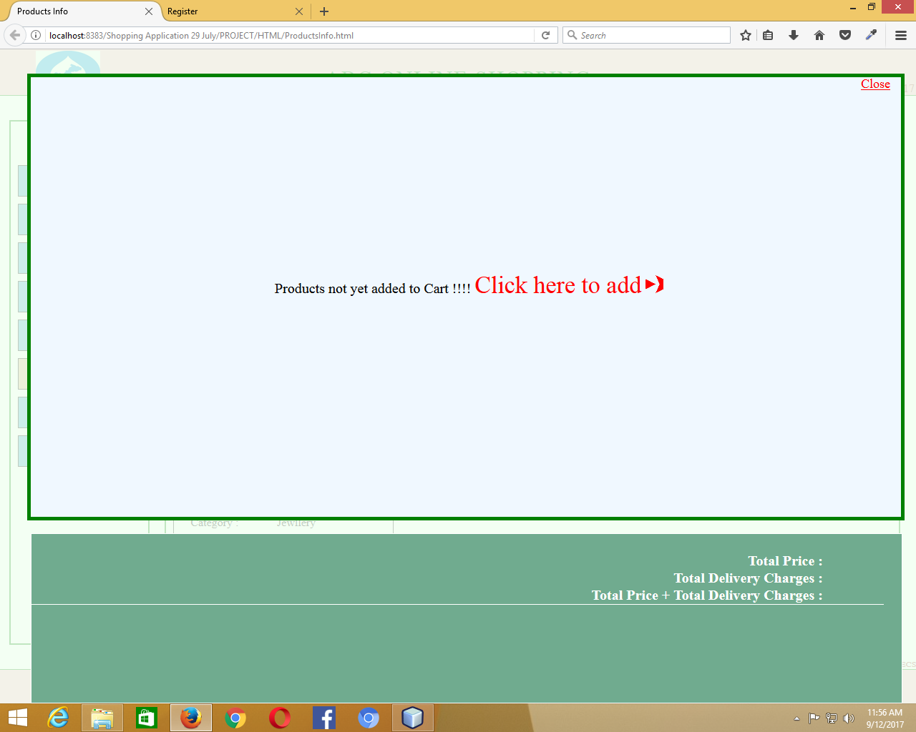

View Cart when no products added

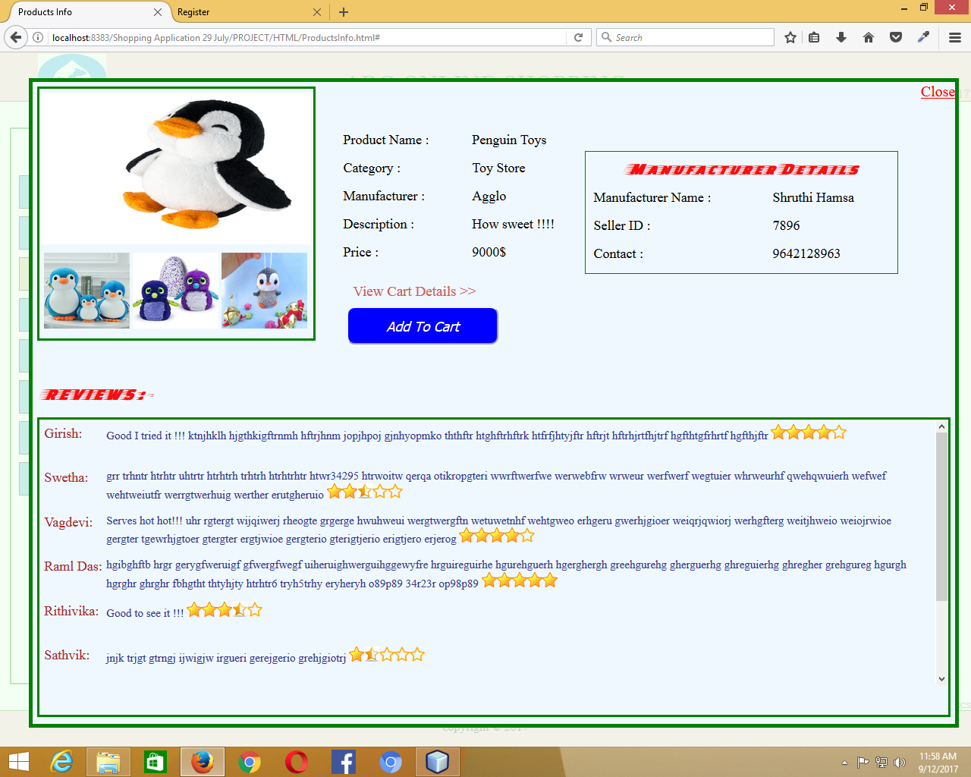

Details of Product when clicked on “Details>>” (a)

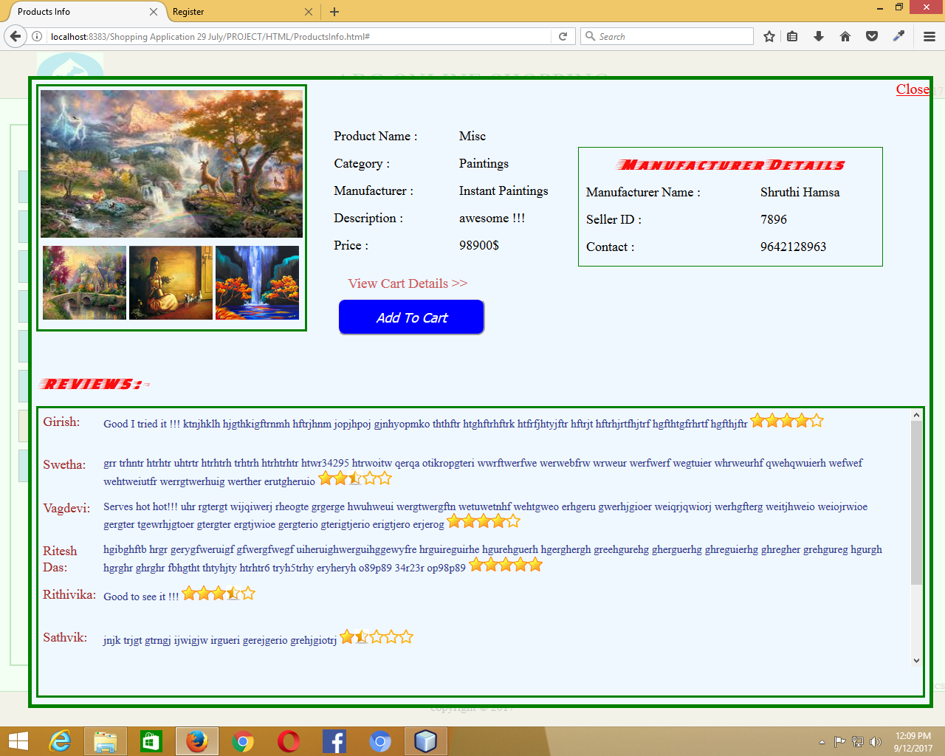

Details of Product when clicked on “Details>>” (b)

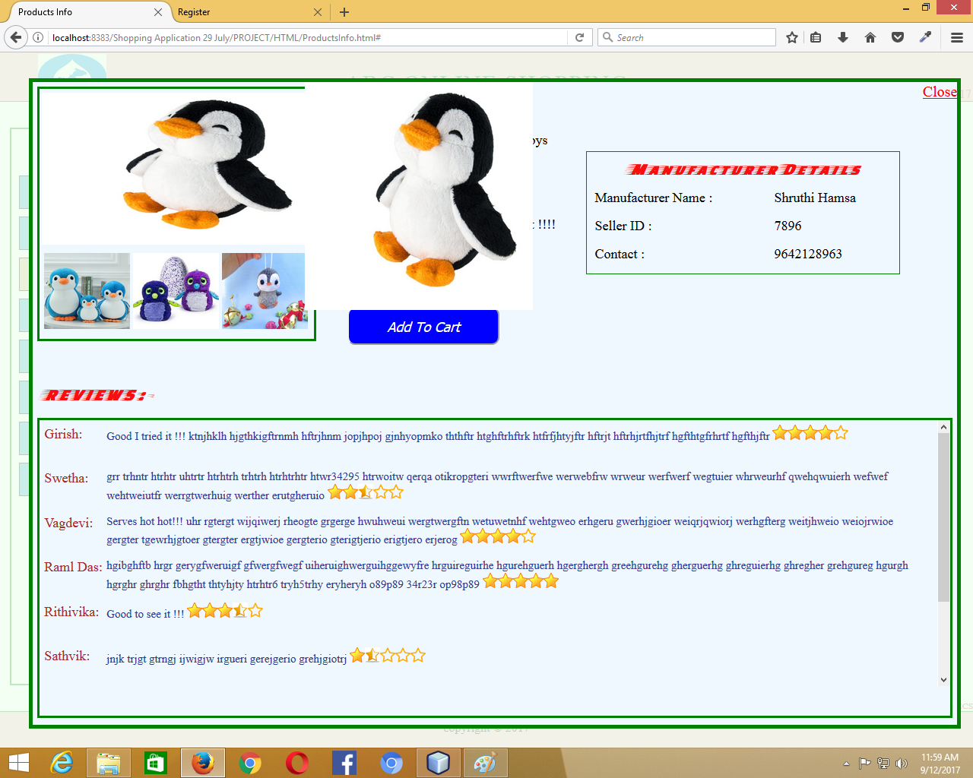

When hovered on the image (a)

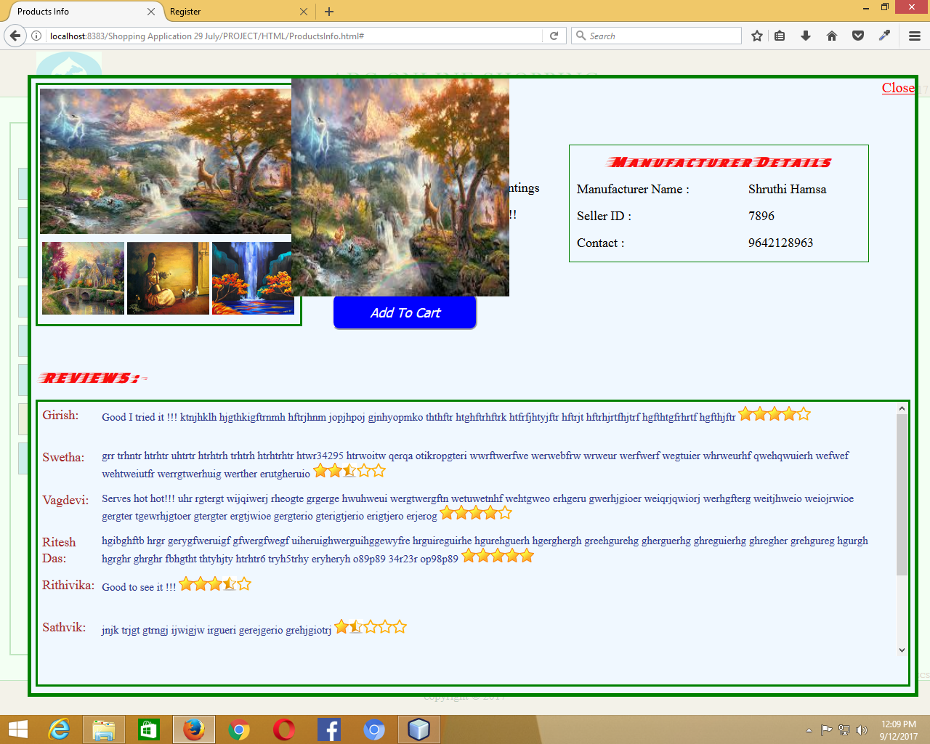

When hovered on the image (b)

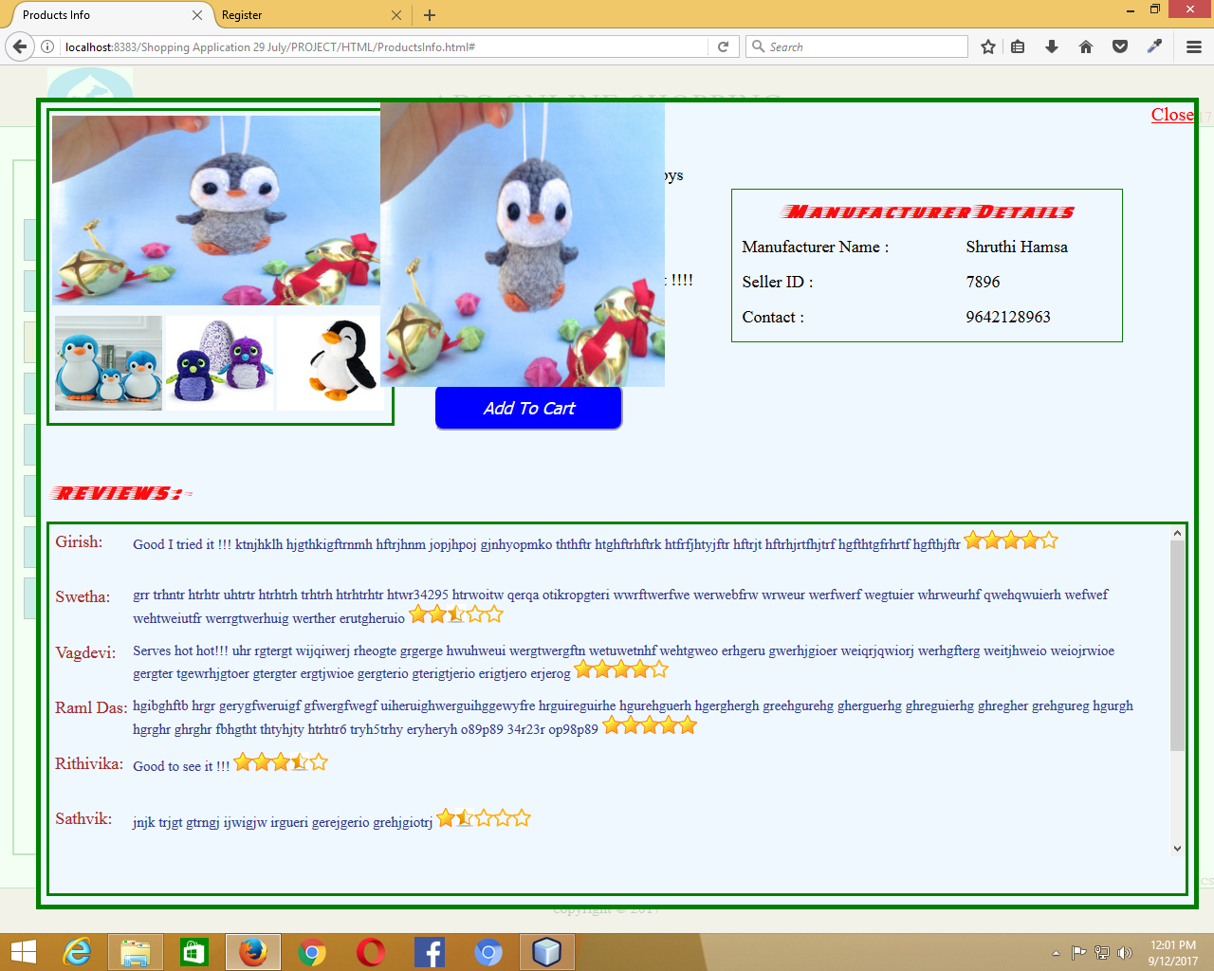

Change of Image (a)

The 3 images which are below the main image can be exchanged to the place of main image so that user can have glance at all the images in a better way.

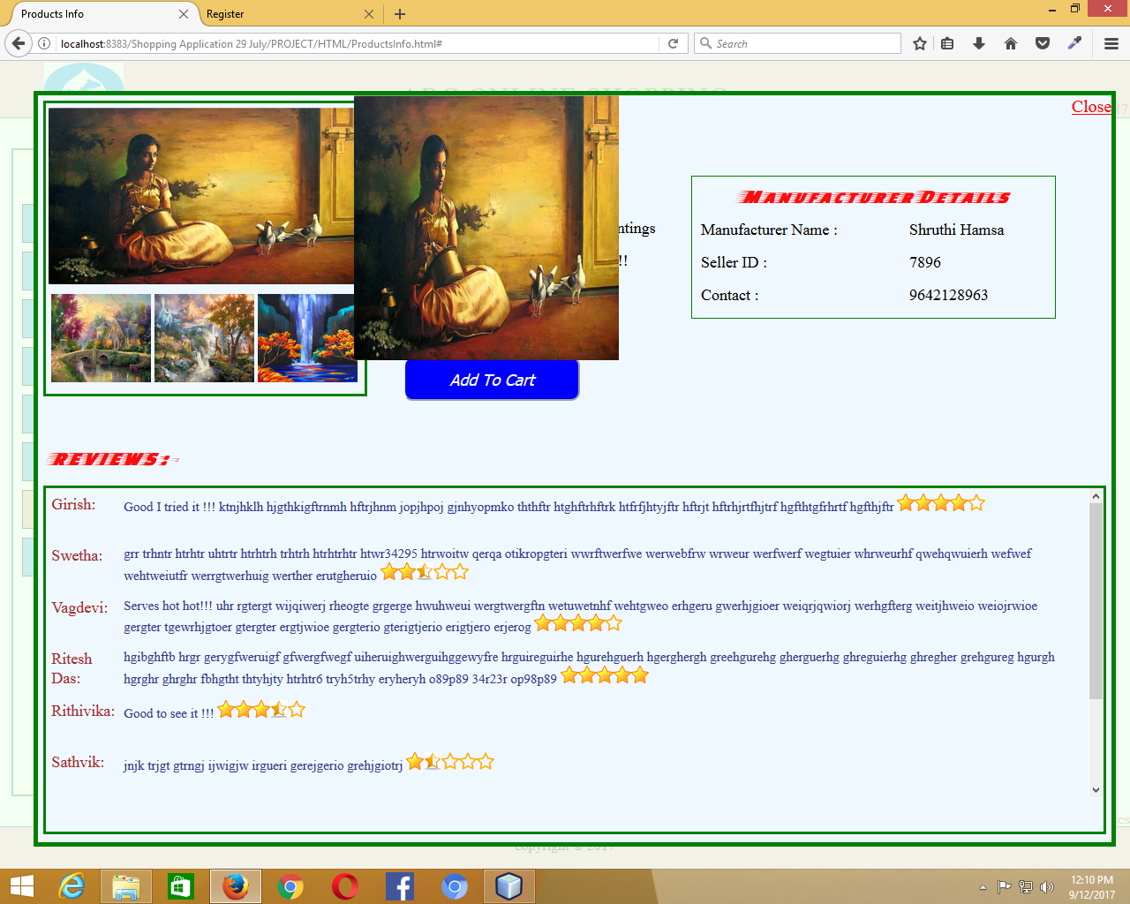

Change of Image (b)

When the products been added to cart, we can add the product either from “All Categories List” or “individual Categories List” or “Details>>”. After adding the product to the cart, we cannot add the same product again to the cart by choosing the product from the other option.

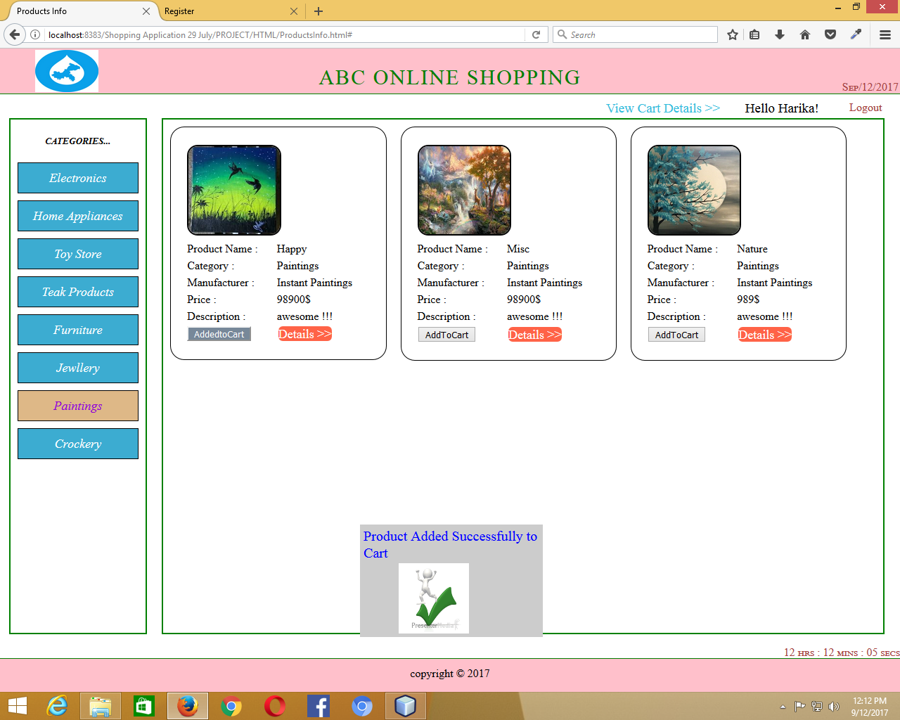

Product added to Cart from the category Paintings List

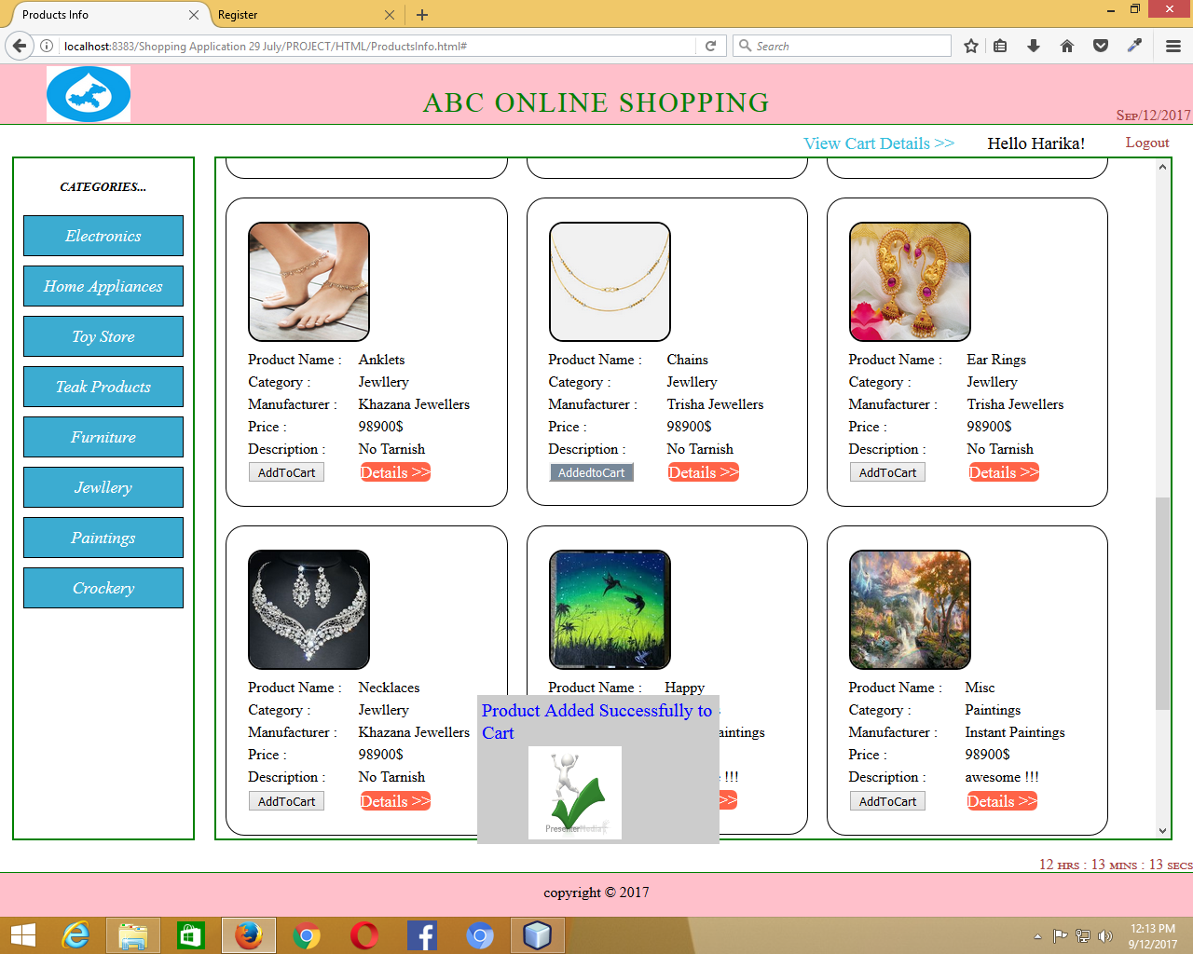

Product added to Cart from All Categories List (a)

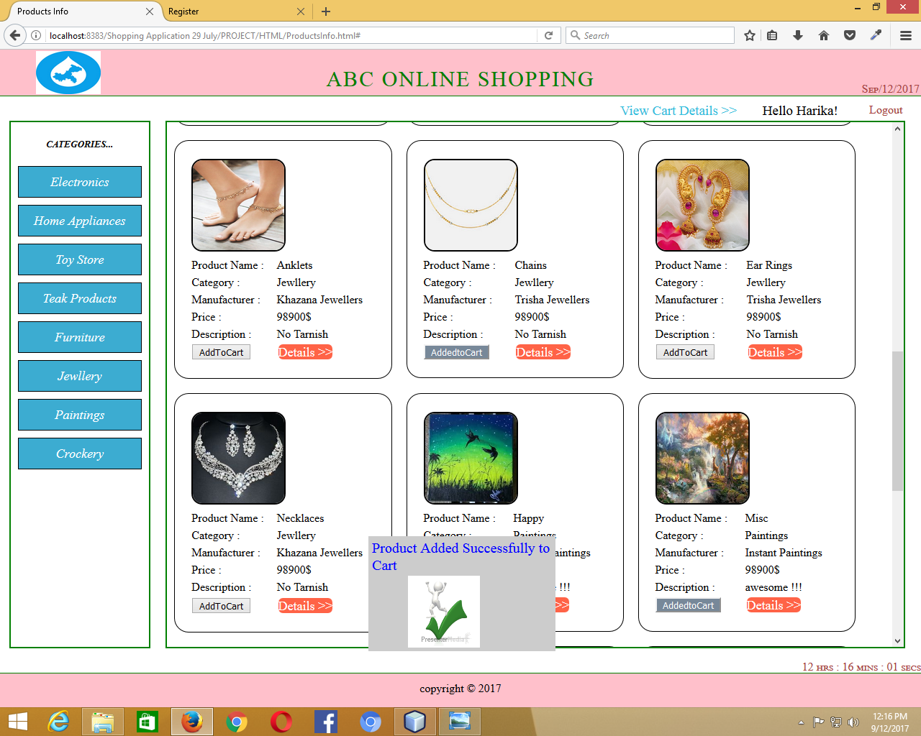

Product added to Cart from All Categories List (b)

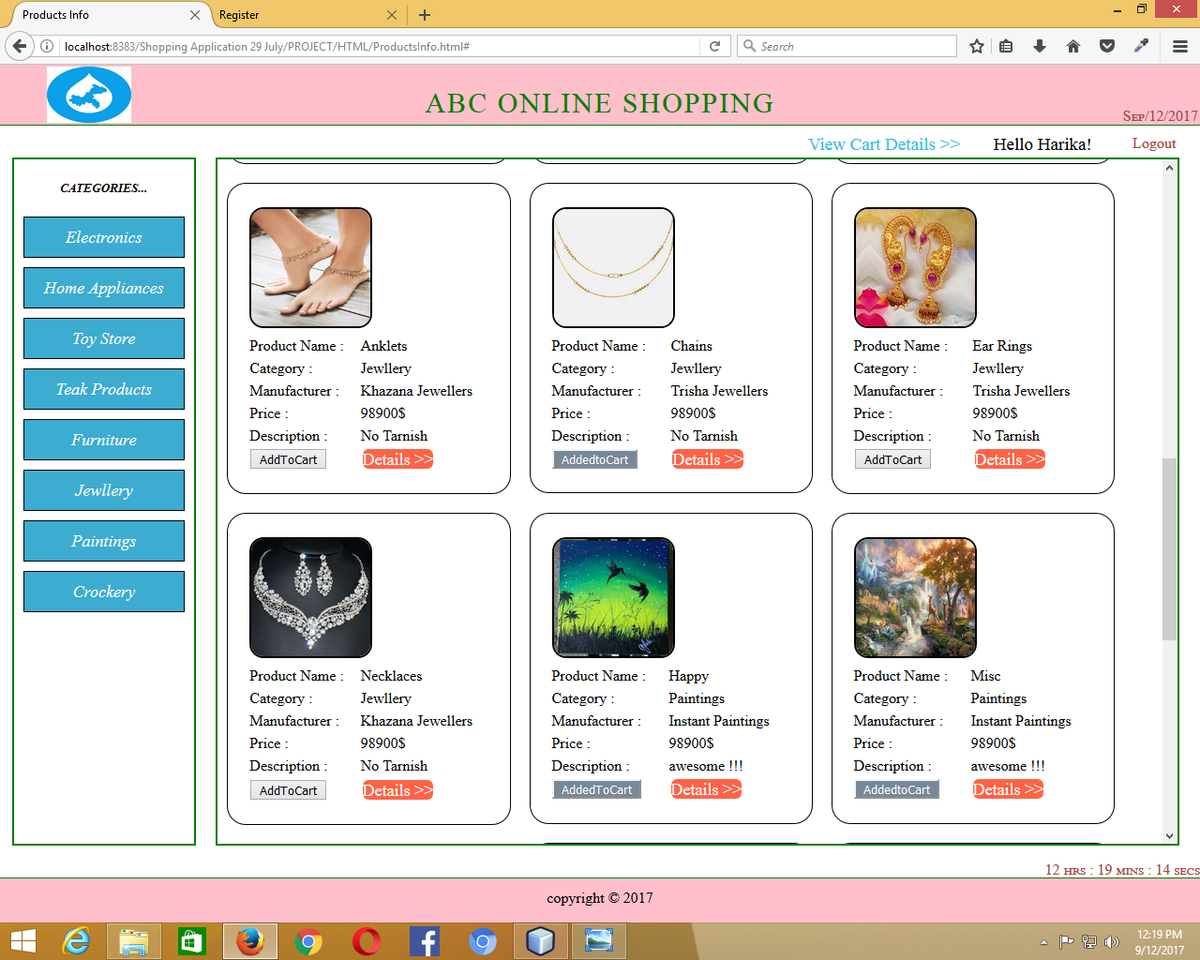

Products Added to Cart are seen in All Categories List

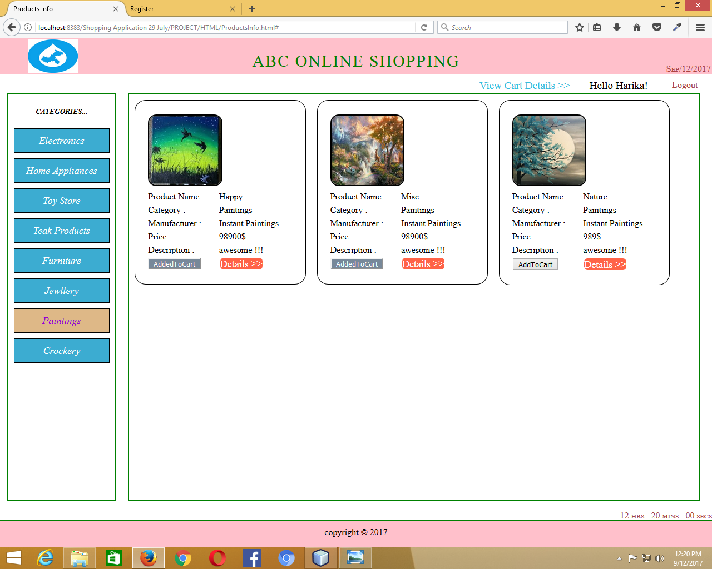

Products seen Added even when searched based on Categories List (Paintings)

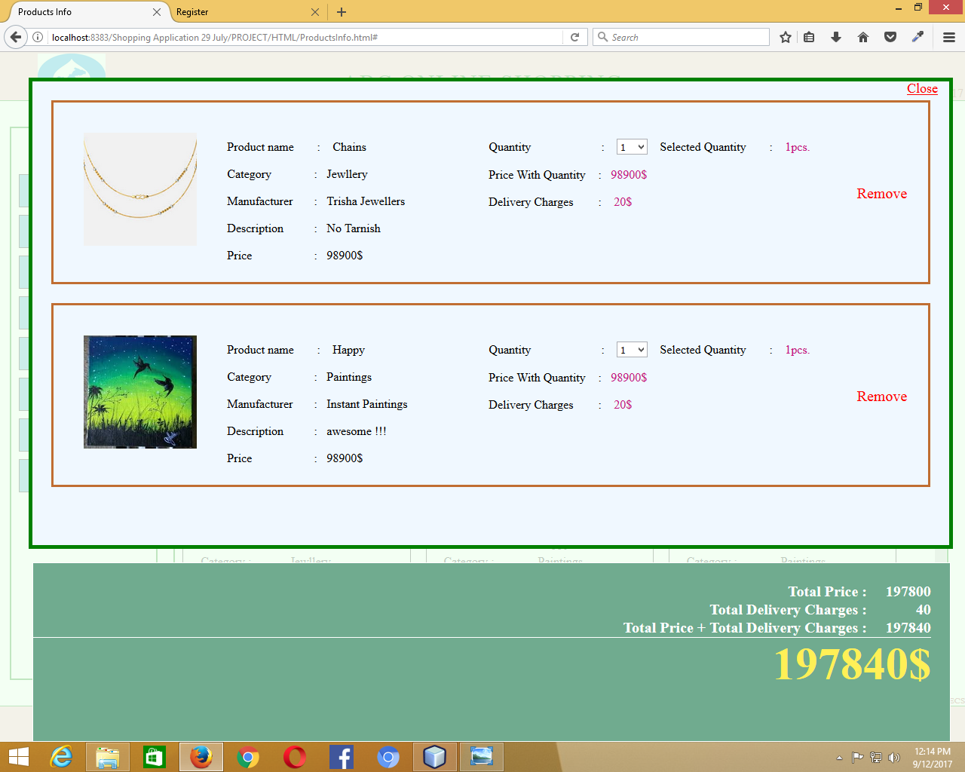

View Cart 1.1

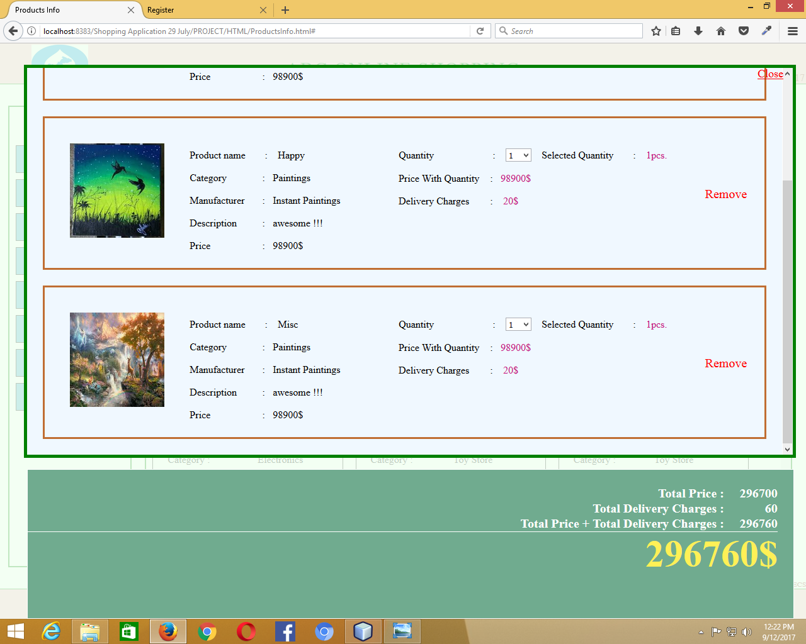

View Cart 1.2

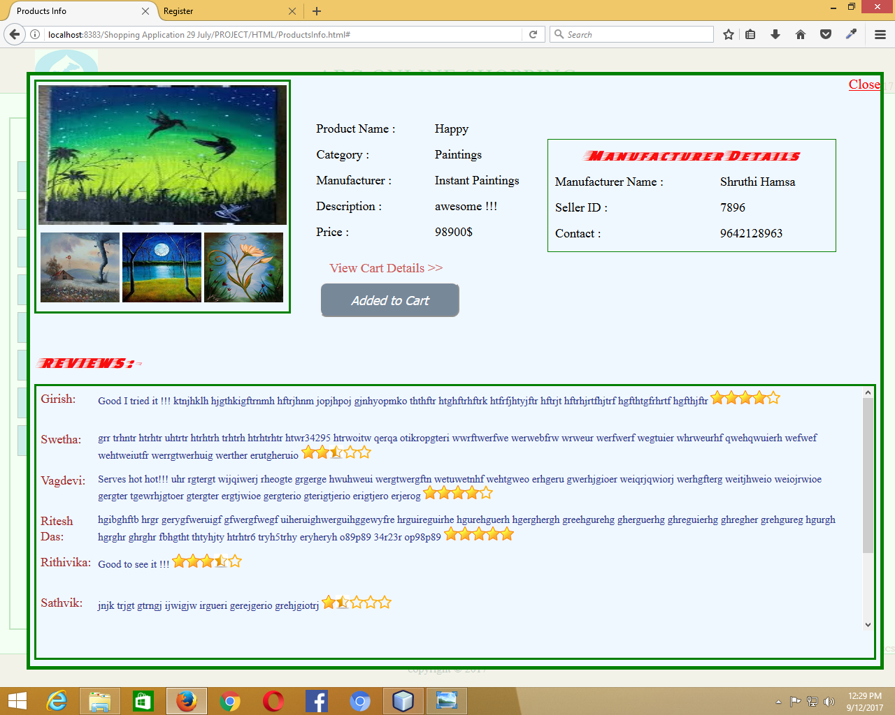

After adding the product to cart then clicking on “Details>>”.We can see that product is already added to cart

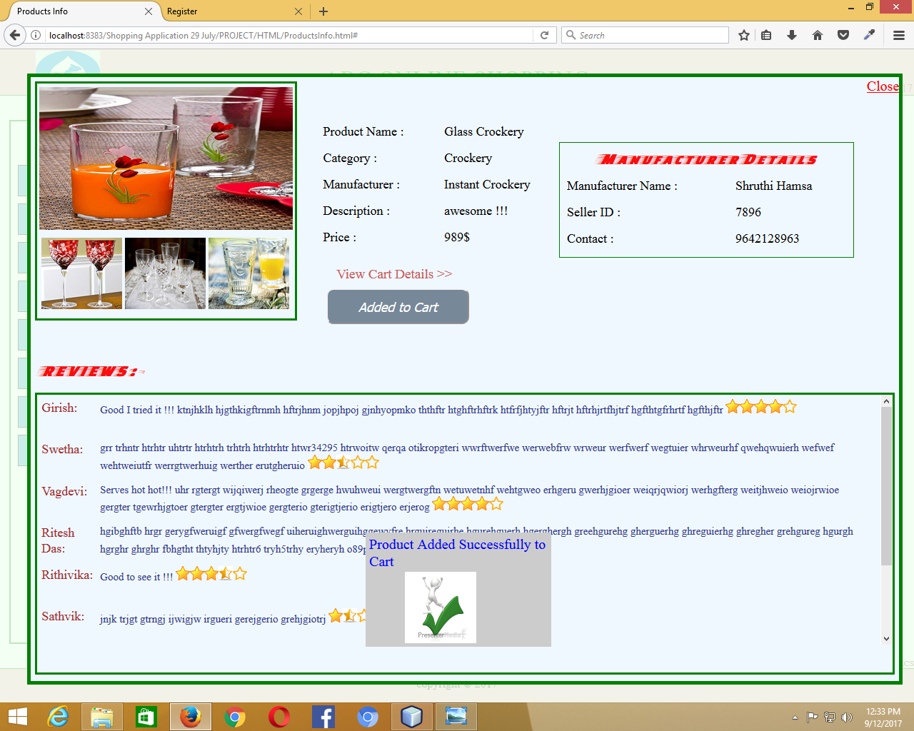

Going to “Details>>” and then clicking on “Add to Cart”

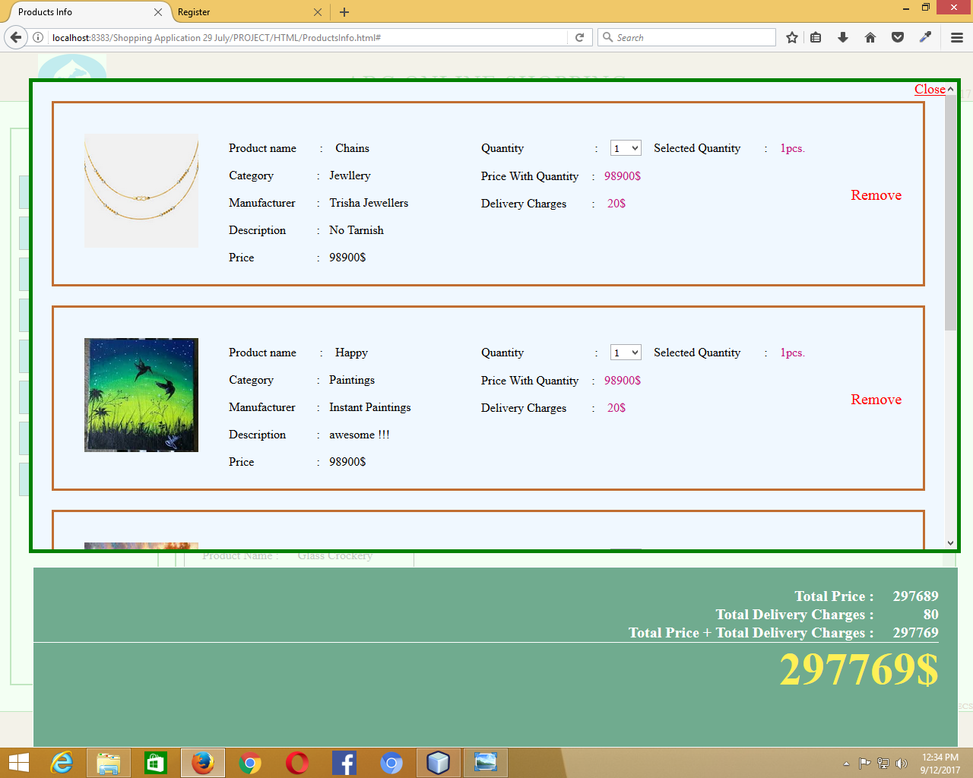

View Cart (2.1)

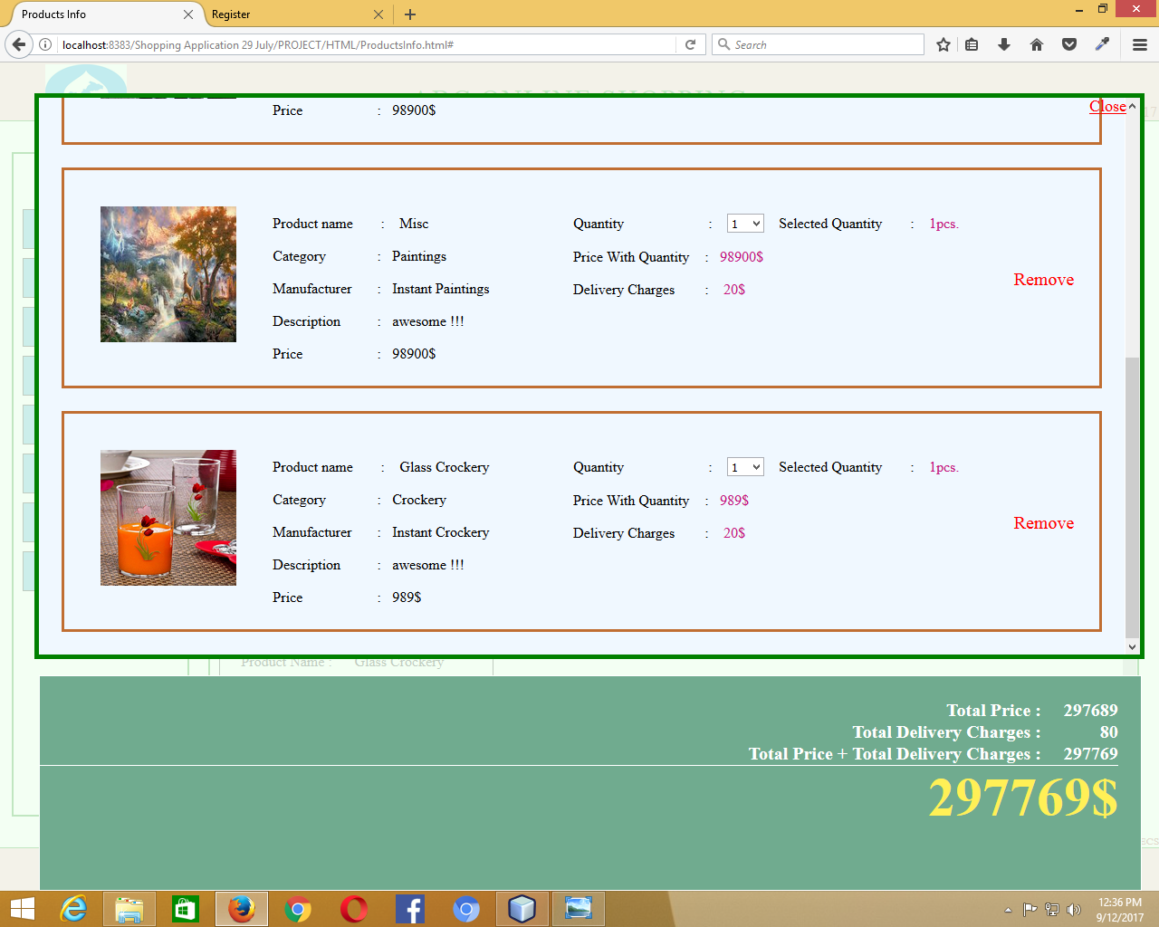

View Cart (2.2)

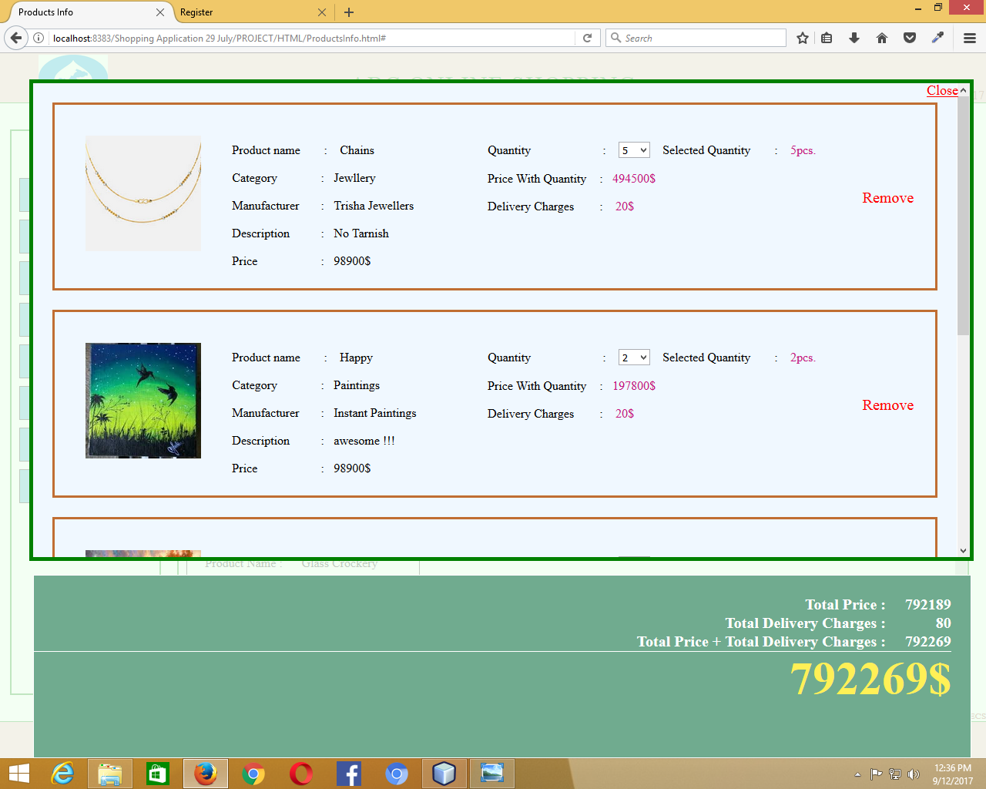

When quantity selected changed the price also changes

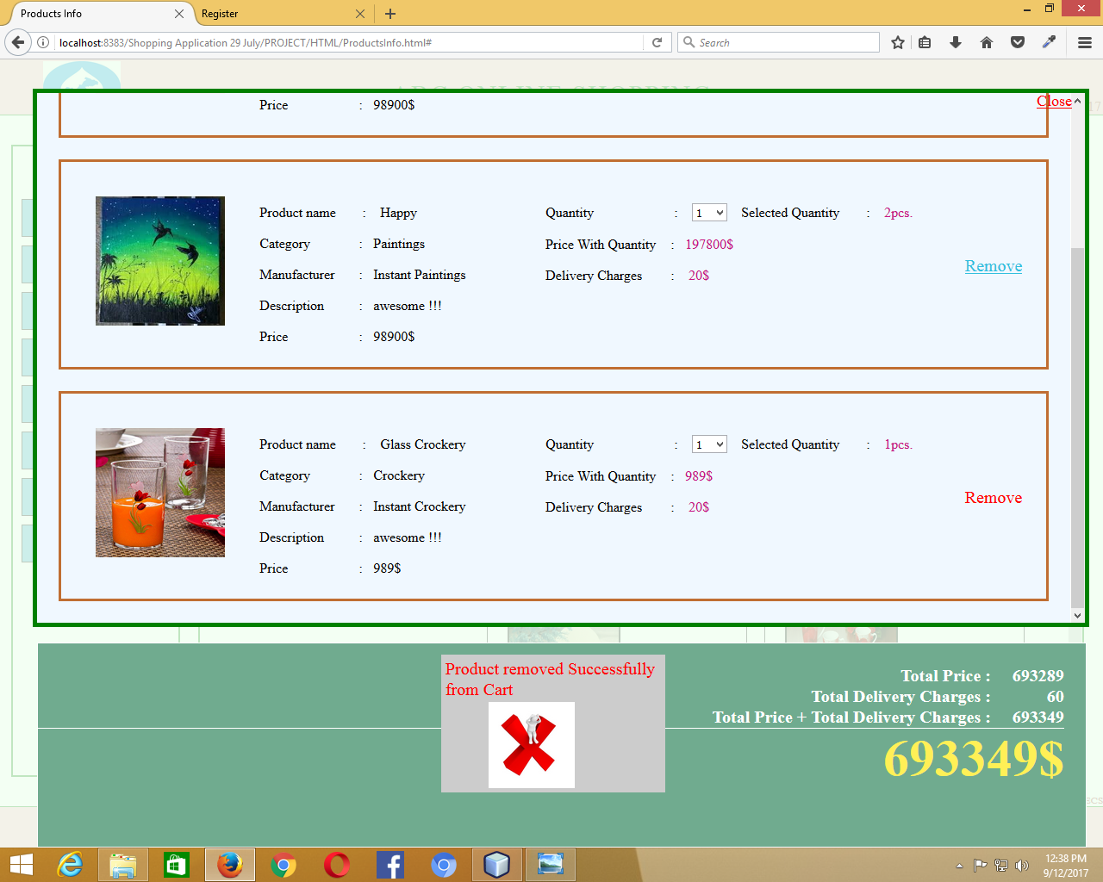

Removal of Product (Painting:- Product Name : Misc) is removed from the cart

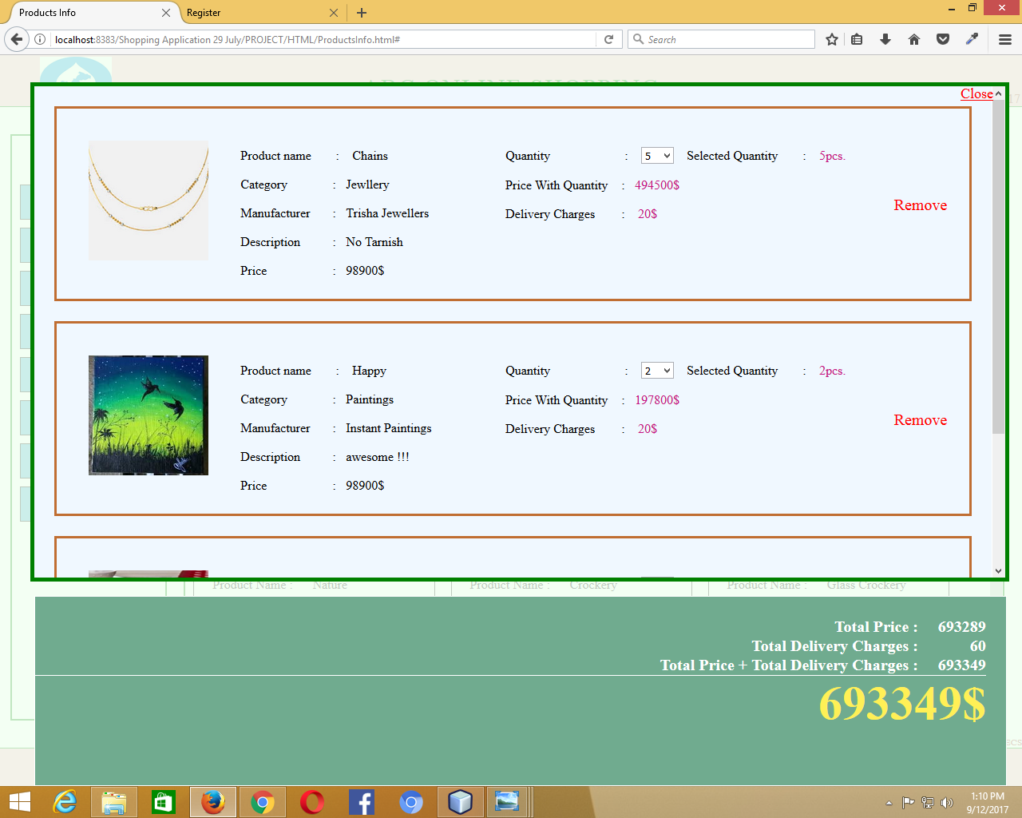

Remaining Products (1.1)

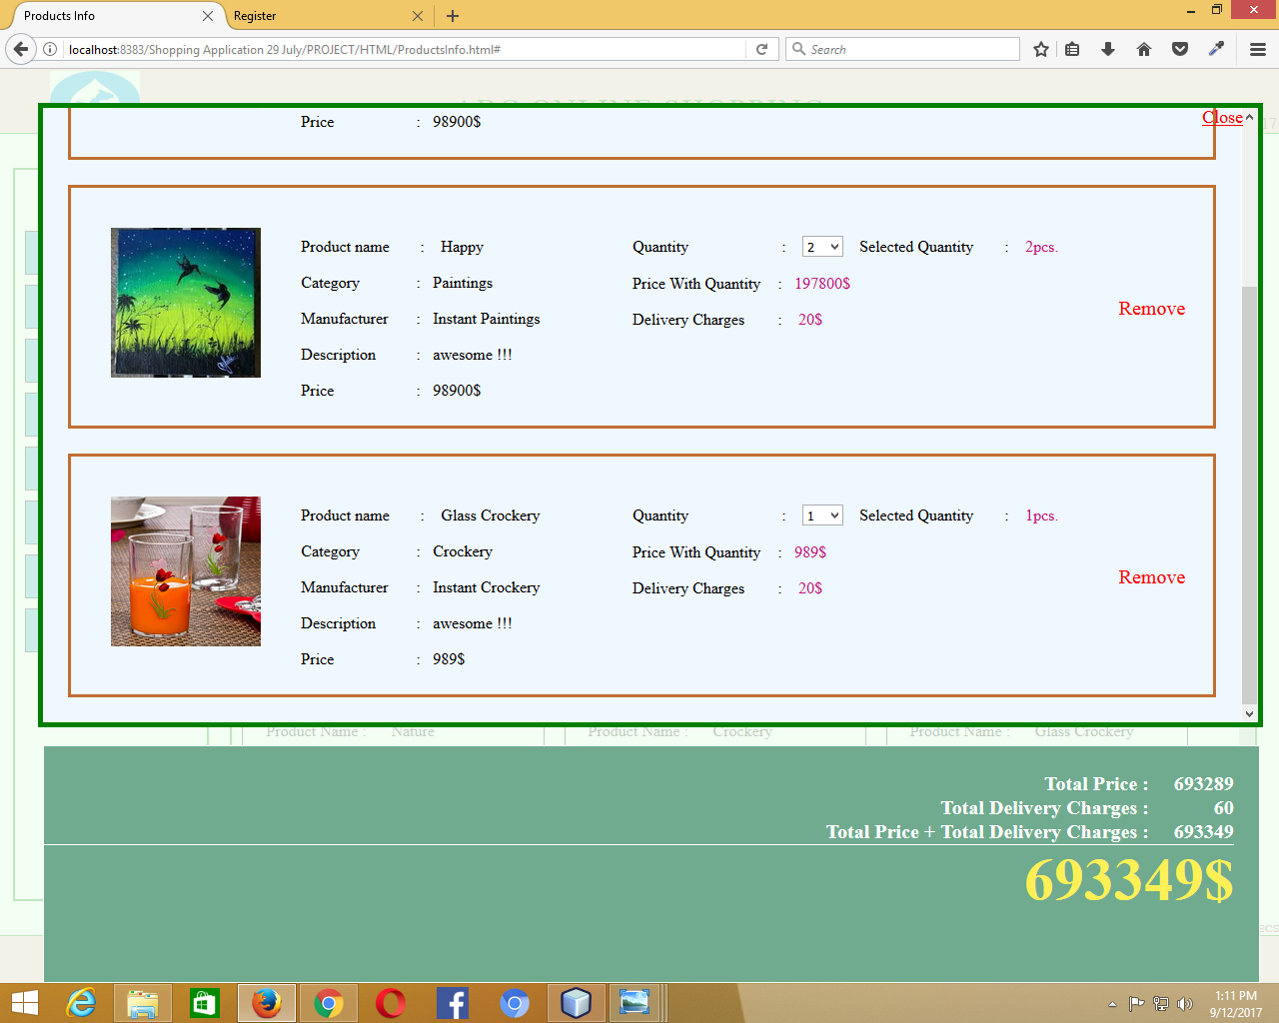

Remaining Products (1.2)

Registration Page:

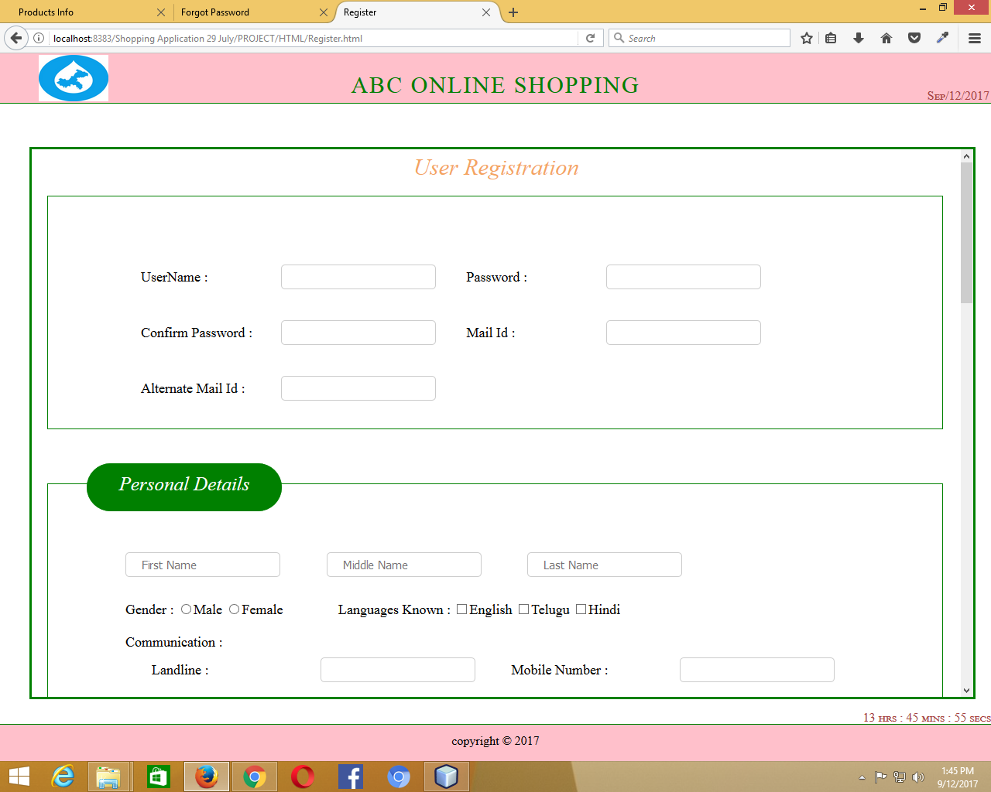

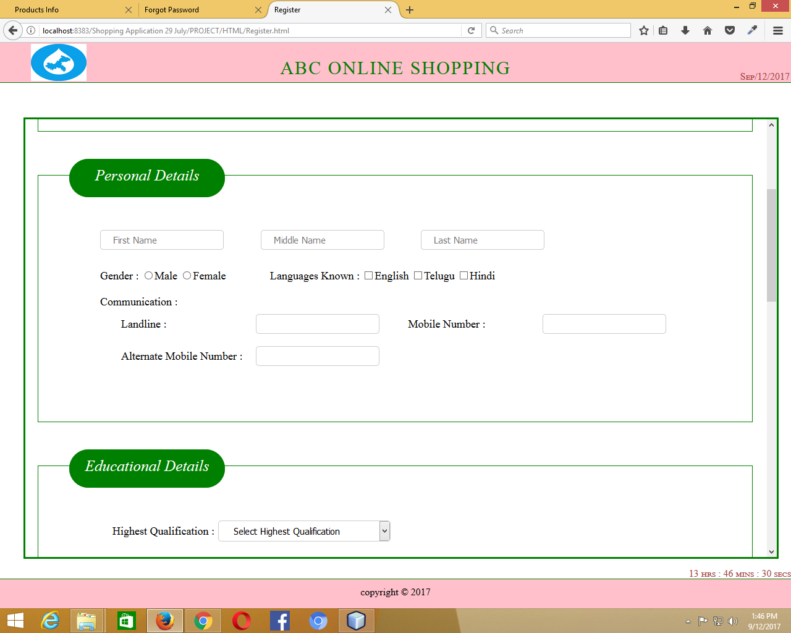

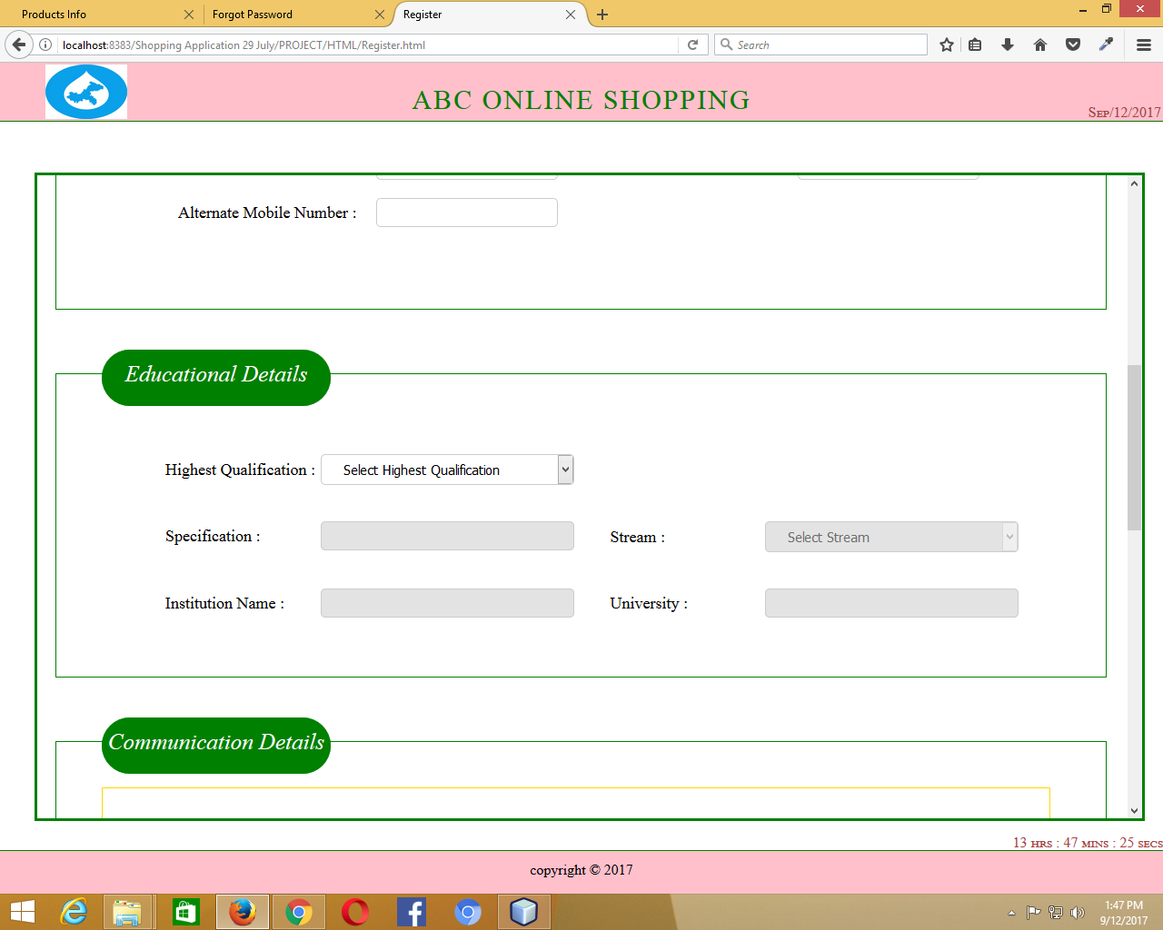

When the user selects “Highest Qualification”, then the other disabled fields get enabled. If the user selects the “Highest Qualification”, enters the data in the remaining fields and now deselects the “Highest Qualification”, then the fields get emptied and again disabled until he selects “Highest Qualification”.

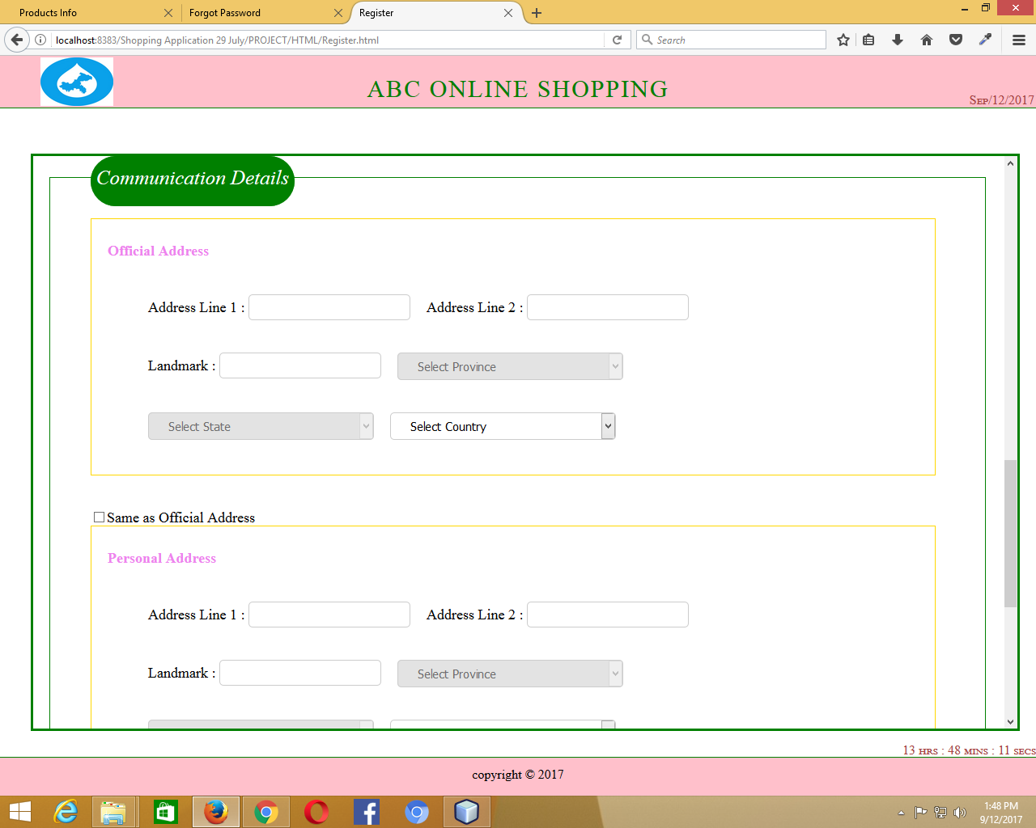

In the Communication Details, first the user has to select Country > State > Province.

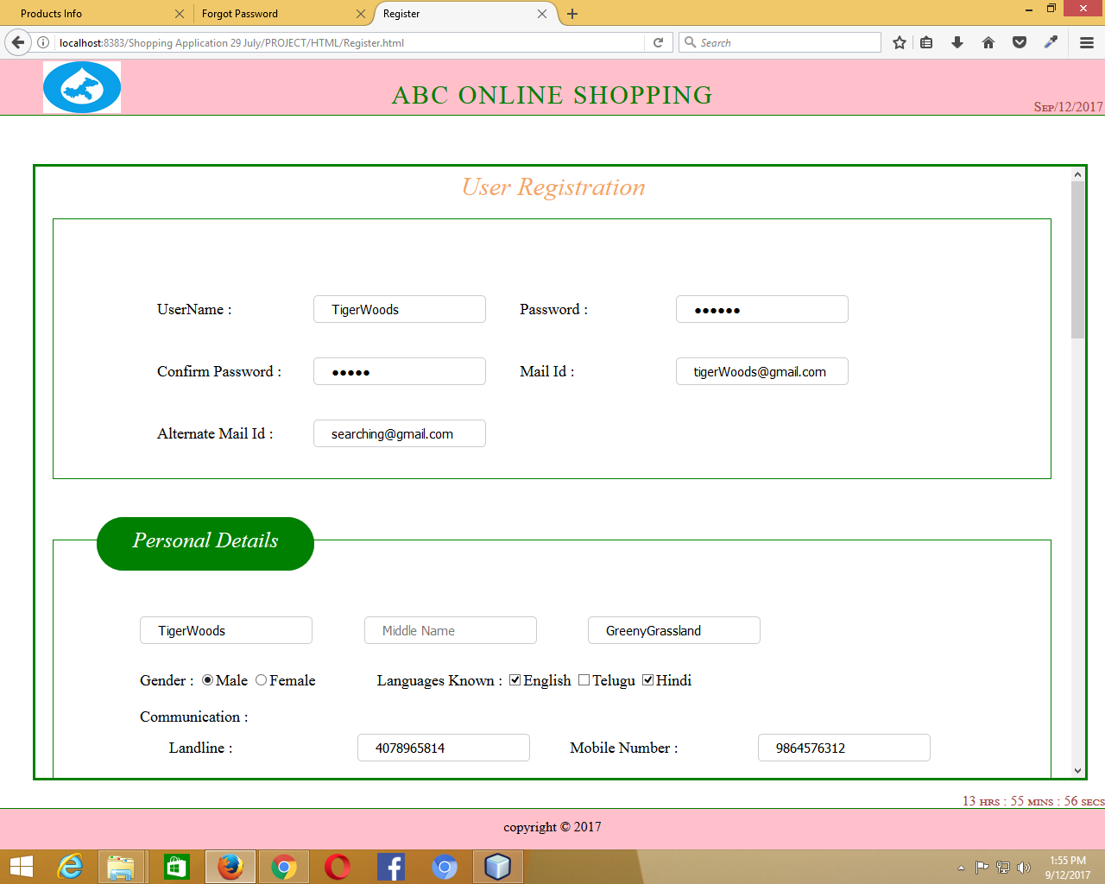

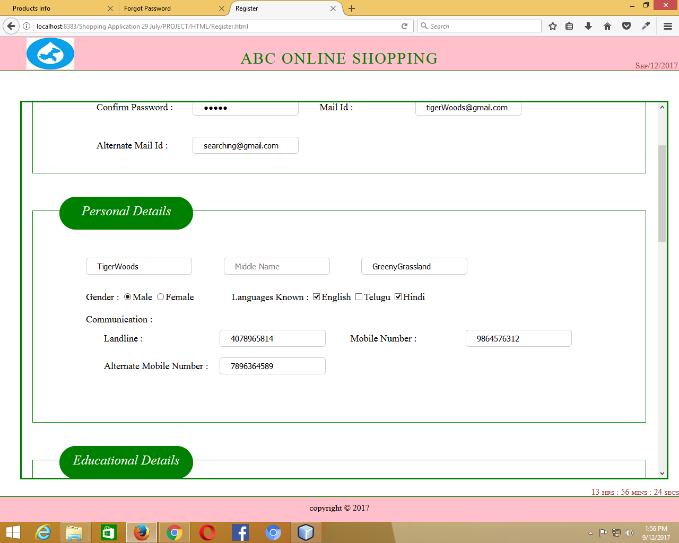

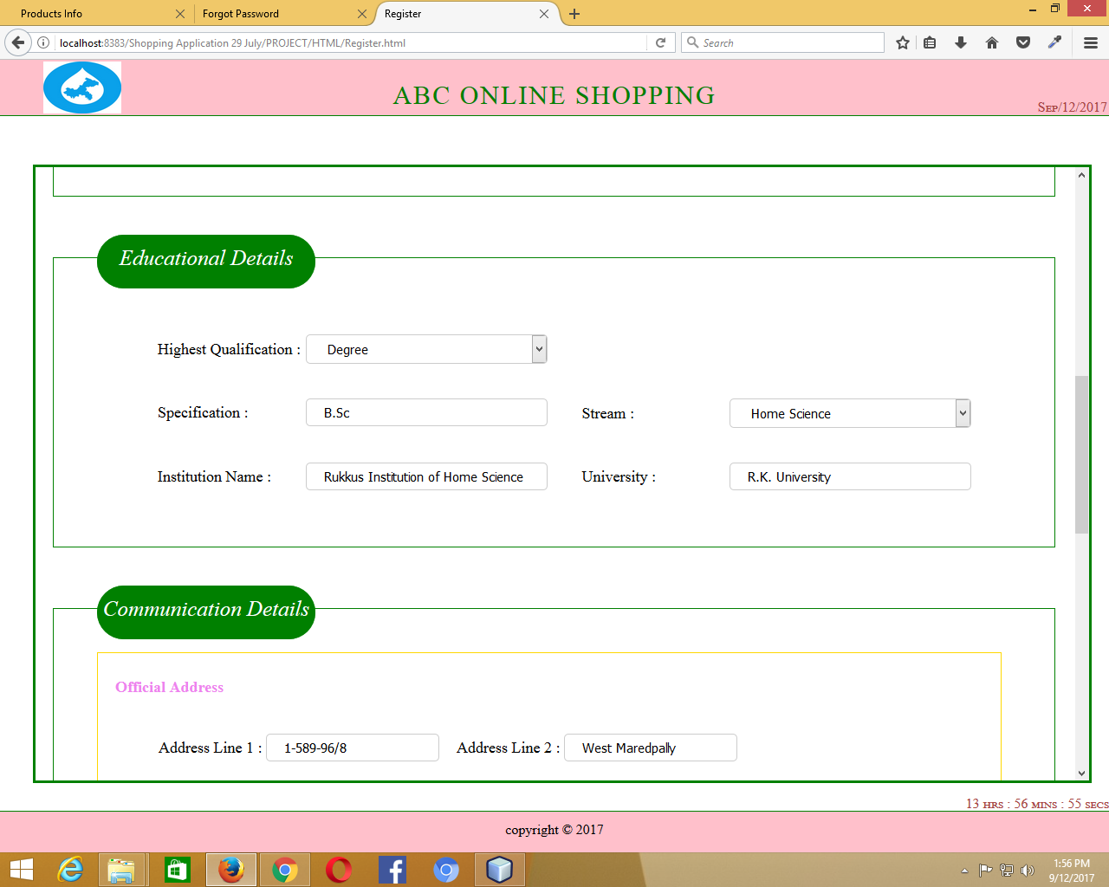

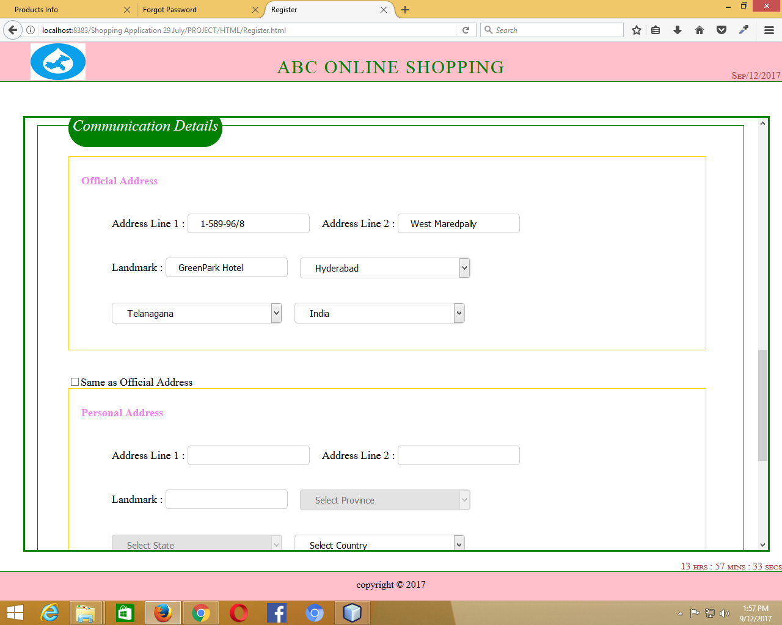

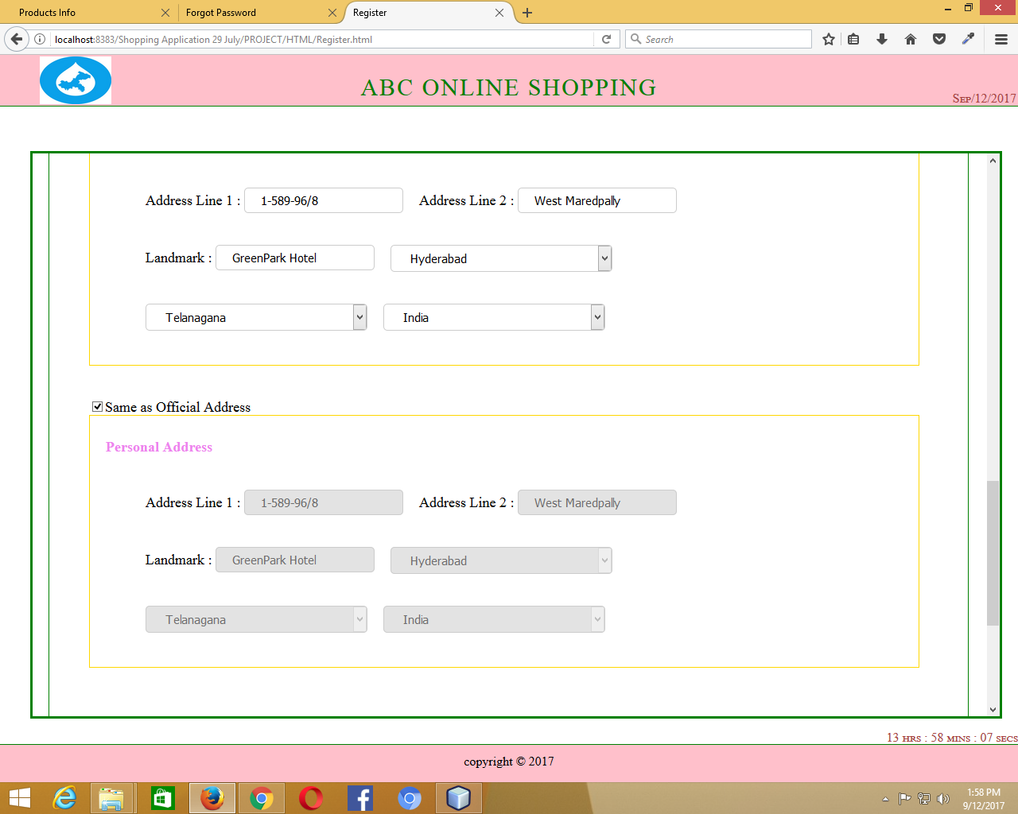

When the user checks the checkbox “Same as Official Address”, then the fields in the “Personal Address” will be filled with the details of the “Official Address”.

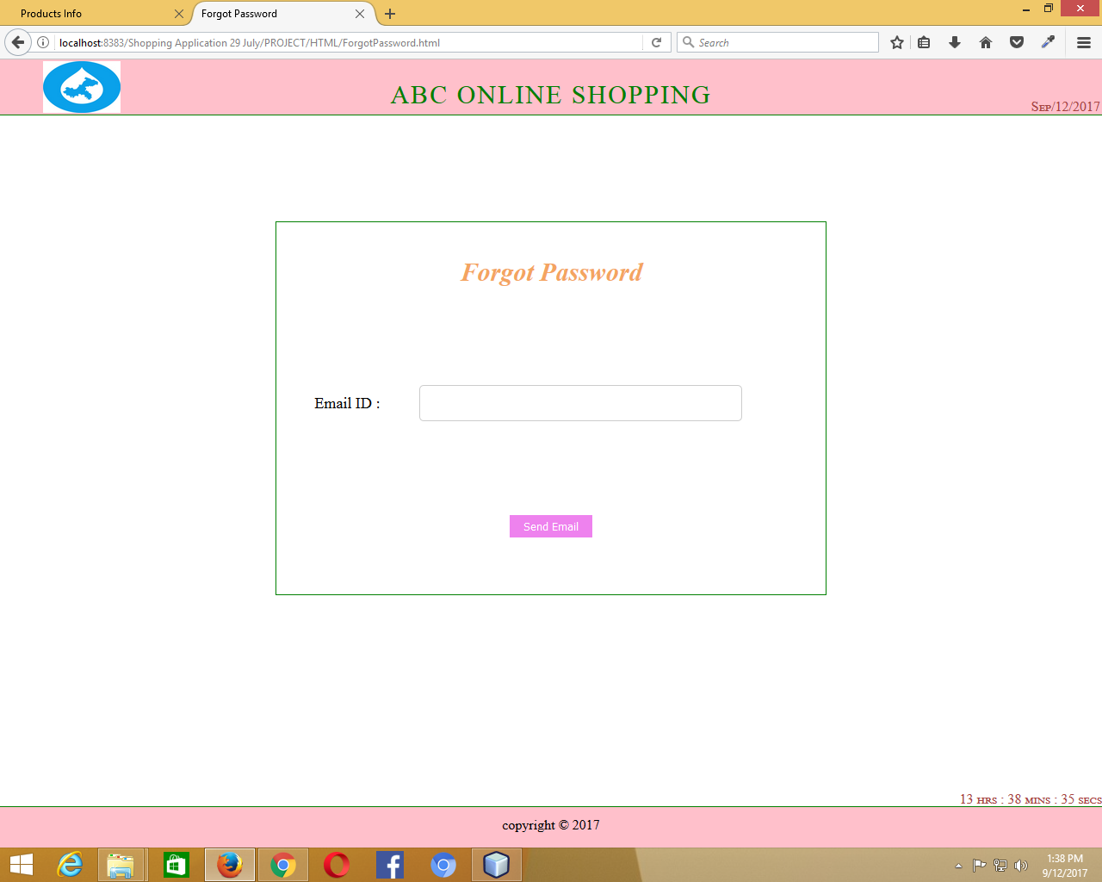

Forgot Password